Name Class Date

While German chancellor Otto von Bismarck is usually credited with unifying
Germany, opinions about him differ. Below, two modern historians comment on
Bismarck and his political accomplishments. ♦ As you read, think about the point of
view each writer presents. Then, on a separate sheet of paper, answer the questions that follow.

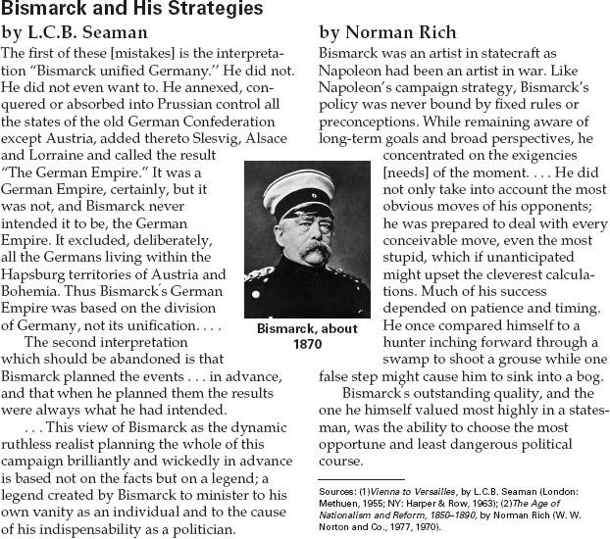

1. Why does Seaman say that the empire
Bismarck created was not really a unified
German empire?
2. What does each of the writers say about
Bismarck’s methods of planning and carrying
out strategy?
3. Identify Fact Versus Opinion Which of the
passages appears to be based more on fact
and which appears to be based more on
opinion? Explain your answer.

28
Name Class Date

The idea of a unified Italy gained strength under Napoleon, and harsh rule by
Austria led to revolution. One outspoken leader for Italian unity was the composer
Giuseppe Verdi, whose words and music inspired many patriots. ♦ As you read, think
about the influence that artists can have on history and politics. Then, on a separate sheet of
paper, answer the questions that follow.

Giuseppe Verdi (1813–1901)
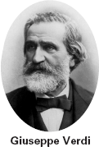
Few great musicians have been as deeply
involved in politics as the composer Giuseppe
Verdi was in the movement for Italian unity
and freedom from Austrian rule. The theme
of liberty and opposition to tyranny runs
through his operas and choral works. Many
of Verdi’s operas faced censorship by the
Austrian government, who would not let
them be presented because the plots
portrayed rulers as unjust or showed
other ideas they thought “danger-
ous.” Sometimes Verdi rewrote to
satisfy the censors, but the message
usually still came through.
In Nabucco (1842), Verdi’s first
successful opera, a chorus of
captives in the ancient Babylon of
Nebuchadnezzar sing movingly about
their hopes for freedom. Italian patri-
ots borrowed the song, and it remains a
favorite patriotic song in Italy. Even the
letters of Verdi’s name became part of the
Italian nationalist movement. The crowds
that shouted “Viva Verdi” were using a
widely understood shorthand phrase for
“Viva Vittorio Emmanuale Rei de Italia”
(Long live Victor Emmanuel, King of Italy).
The small village where Verdi was born in
1813 was part of Napoleon’s conquests in
Italy, but soon came under Austrian rule after
Napoleon’s defeat a few years later. Verdi’s
family was poor, and he received his first
music lessons from the village organist. A
wealthy local merchant recognized his talent,
and at 18, Verdi went to Milan to study. His
first works—which failed—were produced at
the famous La Scala opera house, but so were
many later successes.
By the time he was in his thirties,
Verdi was the outstanding composer
of Italian operas. Audiences loved his
dramatic stories, strong characters,
and stirring melodies. His career
continued for fifty years, and he
became internationally famous.
When Italy achieved unity in 1860,
Verdi served briefly in its parliament at
the urging of Count Cavour, but soon
went back to concentrating on music.
Some of Verdi’s best-loved operas are
Rigoletto (1851), La traviata, (1853), and Aïda
(1871). Aïda was set in Egypt, and was com-
missioned by the ruler of Egypt to celebrate
the opening of the Suez Canal. Verdi adapted
several of Shakespeare’s plays into operas,
including Otello (1887) and his last opera,
Falstaff, written when he was 80 years old. He
also wrote religious choral works. His great
1874 Requiem [Mass for the dead] honored an
Italian patriot, Alessandro Manzoni.

1. How did Verdi’s work add to the cause of
Italian unity?
2. What double meaning did the cheer “Viva
Verdi” have for the crowds who used it?
- Predict Consequences What kind of effects
do you think censorship can have on the
work of artists, writers, and musicians? How
do you think it affected Verdi’s work?

29
Name Class Date

Harsh conditions and brutal pogroms drove many Jews to flee tsarist Russia in the late
1800s. One emigrant was Anzia Yezierska (1885–1970), who settled in New York City
and became an American citizen. Later, she drew on her experiences to write Hungry
Hearts, a collection of short stories. In this excerpt from a story in the collection, the
narrator recounts the excitement in a small Russian village caused by the arrival of a
letter from America. ♦ As you read, notice the reaction of the family and villagers to the
letter. Then, on a separate sheet of paper, answer the questions that follow.

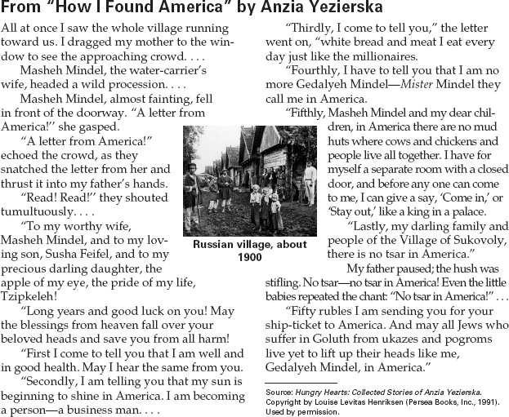

1. What role does the narrator’s father seem to
play in the village?
2. Do you think a letter from America was a
common occurrence? Why or why not?
3. Draw Conclusions What reasons for emigrat-
ing to America are clear from Mindel’s letter?

30
Name Class Date

Tsar Nicholas I feared the new ideas that swept Europe after the revolutions of 1848
and dealt harshly with liberal groups. The young writer Feodor Dostoyevsky, a
member of one such group, was arrested in St. Petersburg in 1849 and sentenced to
death. Here is his story, told partly through letters he wrote to a friend. ♦ As you
read, think about the kind of government that could treat its citizens this way. Then, on a
separate sheet of paper, answer the questions that follow.
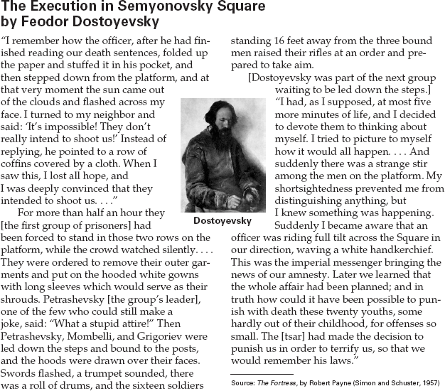

1. What convinced Dostoyevsky that he and
his friends were really going to be shot?
2. Identify Assumptions What did the tsar
intend this staged execution to achieve?
What does this show about the tsar’s ideas?
3. Activity Suppose that you are a foreigner
from a democratic country, visiting Russia in
1849. Draw an editorial cartoon commenting
on this incident and what it shows about
Nicholas’s rule.

