Name Class Date

Focus Question: How did Otto von Bismarck, the chancellor of Prussia,
lead the drive for German unity?
As you read this section in your textbook, complete the following chart to record the
sequence of events that led to German unification. Some items have been completed
for you.

Napoleon raids German lands.

Napoleon conquers and partially unifies German states.

As states gain freedom from French rule,
people demand a unified Germany.

Prussia creates an economic union called the Zollverein.

112
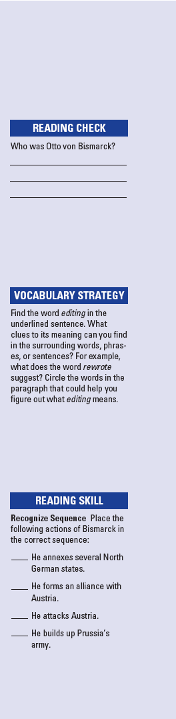
Name Class Date

In the early 1800s, German-speaking people did not live in one
nation. They were scattered among several German states,
parts of Prussia, and the Austrian empire. Napoleon dissolved
the Holy Roman Empire and organized some German states
into the Rhine Confederation. Napoleon’s actions helped
develop German national identity. Not everyone wanted
French rule. They fought to free their lands and began to
demand one German nation for all German-speaking people.
After Napoleon’s defeat, the Congress of Vienna created the
German Confederation, a weak alliance of German states head-
ed by Austria. In the 1830s, Prussia created an economic union
called the Zollverein. This union removed tariffs between
German states. Still, the German people did not live in one,
unified German nation.
In 1862, King William I named Otto von Bismarck as the
chancellor of Prussia. Bismarck wanted to unite the German
states under Prussian rule. He was very skillful at Realpolitik,
or practical politics based on the needs of the state. First,
Bismarck built up the Prussian army. He led Prussia into three
wars, gaining land for Prussia in each one.
In 1864, Bismarck formed an alliance with Austria. In 1866,
however, he made up an excuse to attack Austria. After its vic-
tory, Prussia annexed, or took control of, several northern
German states. This angered the French ruler, Napoleon III.
Bismarck rewrote and released to the press a telegram that
reported on a meeting between William I of Prussia and the
French ambassador. Bismarck’s editing made it seem that
William I had insulted the French. Furious, Napoleon III
declared war on Prussia. This is what Bismarck had wanted.
Supported by troops from other German states, Prussia defeat-
ed the French.
Delighted by the victory, German princes asked William I
to take the title kaiser, or emperor. He agreed. In 1871,
Germans celebrated the birth of the Second Reich, or empire.
Review Questions
1. What was the Zollverein and what did it accomplish?

2. How did Bismarck use war to strengthen Prussia?

113

Name Class Date

Focus Question: How did Germany increase its power after unifying in
1871?
As you read this section in your textbook, complete the following chart to record the
causes and effects of a strong German nation. Some items have been completed for you.
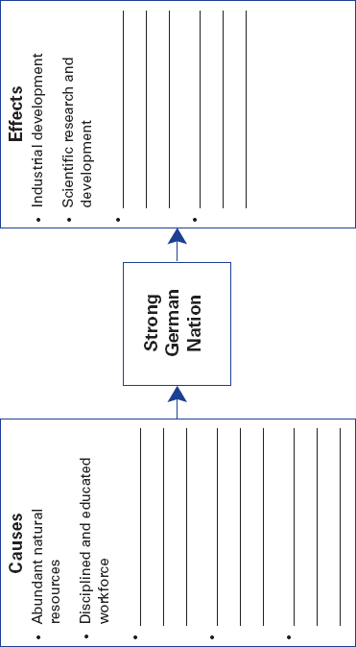

114

Name Class Date

After 1871, the new German empire became an industrial
giant. There are several reasons why this was possible.
Germany had large iron and coal resources. These are the basic
ingredients for industrial development. It also had a disci-
plined and educated workforce. The middle class helped cre-
ate a productive and efficient society, too. The country’s
growing population also provided a huge home market for
goods. It also created a supply of workers.
Industrialists saw the value of science in business. They
developed new products, such as synthetic chemicals and dyes.
Both industrialists and the government encouraged scientific
research and development. The German government also sup-
ported economic development. It issued a single form of money
and reorganized the banking system. The leaders of the new
empire were determined to maintain a strong economy.
As chancellor, Bismarck had several foreign-policy goals.
He wanted to keep France weak. He also wanted to build
strong ties with Austria and Russia. At home, Bismarck
believed the Socialists and the Catholic Church threatened the
new empire. He worried that Socialists would turn workers
toward revolution. He thought Catholics would be more loyal
to the Church than to the state. Bismarck tried to repress both
groups. His efforts, however, backfired. For example, he
launched the Kulturkampf, or “battle for civilization.” It was
meant to make Catholics give their loyalty to the state first,
above the Church. Instead, Catholics rallied behind the Church.
In 1888, William II became the new kaiser. He shocked
Europe by asking Bismarck to resign. William II believed that
his right to rule came from God. Not surprisingly, he resisted
democratic reforms. However, his government still provided
many social welfare programs to help certain groups of peo-
ple. He also provided cheap transportation and electricity.
Review Questions
1. What are two reasons why the new German empire became
an industrial giant?

2. What were Bismarck’s foreign-policy goals?

115

Name Class Date

Focus Question: How did influential leaders help create a unified Italy?
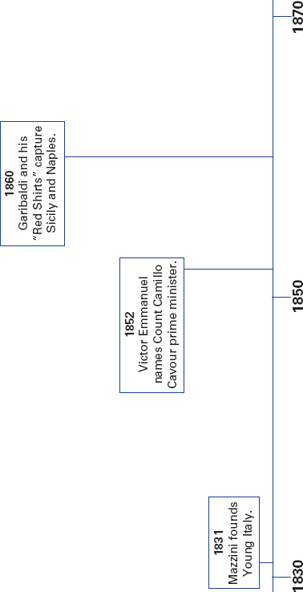
As you read this section in your textbook, complete the following timeline to show the
sequence of events that led to Italian unification. Some dates have been completed for
you.

116

Name Class Date

The people of the Italian peninsula spoke the same language
and shared a common history. However, the region had not
been united since Roman times. By the 1800s, however, patri-
ots were determined to unite Italy. First, Napoleon’s invasions
had sparked dreams of nationalism. Then, Giuseppe Mazzini
founded Young Italy. The goal of this secret society was “to
constitute Italy, one, free, independent, republican nation.” A
united country made economic sense because it would end
trade barriers among the states. It also would encourage indus-
trial development.
Victor Emmanuel II was the king of Sardinia. He wanted to
join other Italian states with his own. Victor Emmanuel made
Count Camillo Cavour his prime minister. Cavour wanted to
end Austrian power in Italy. With help from France, Sardinia
defeated Austria and annexed Lombardy. Also, Austrian-
backed leaders in northern states were overthrown.
In southern Italy, Giuseppe Garibaldi was also fighting for
unification. He had recruited a force of 1,000 red-shirted vol-
unteers. Garibaldi and his “Red Shirts” quickly won control of
Sicily. They then crossed to the mainland and seized Naples.
Garibaldi gave both regions to Victor Emmanuel. In 1861,
Victor Emmanuel II became king of Italy. By 1870, France had
withdrawn its troops from Rome, and Italy acquired Venetia.
For the first time since the fall of the Roman empire, Italy was
united.
The new nation faced many problems, and tensions grew.
There were strong differences between the north and south.
The north was richer and had more cities. In contrast, the
south was poor and rural. Anarchists, people who wanted to
abolish all government, turned to violence. Despite these prob-
lems, Italy’s economy developed. As the population grew,
however, emigration offered a chance for a better life. Many
Italians left for the United States, Canada, and Latin American
nations.
Review Questions
1. What sparked dreams of national unity in Italy?

2. Why did a unified Italy make economic sense?

117

Name Class Date

Focus Question: How did the desire for national independence among
ethnic groups weaken and ultimately destroy the Austrian and Ottoman
empires?
As you read this section in your textbook, complete the following table to record some
major events in Austrian history during the 1800s. Some dates have been completed
for you.
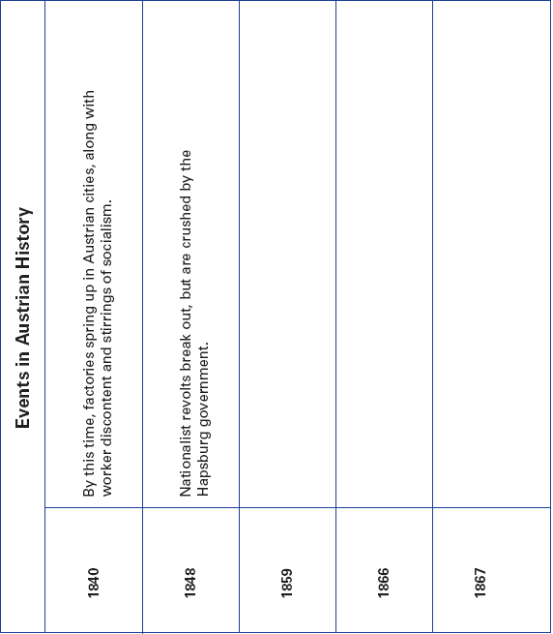

118

Name Class Date

In 1800, the Hapsburgs were the longest-reigning family in
Europe. Their Austrian empire was home to many ethnic
groups, including German-speaking Austrians, Slavs,
Hungarians, and Italians.
By the 1840s, the empire faced many problems associated
with industrial life. Also, nationalism threatened the empire.
The Hapsburgs ignored these issues as long as they could.
When revolts broke out in 1848, the government crushed them.
During this time of unrest, 18-year-old Francis Joseph came to
the Hapsburg throne. In an attempt to strengthen the empire, he
granted some limited reforms. He also created a constitution,
but the majority of power remained with German-speaking
Austrians. This did not satisfy most of the other ethnic groups.
Austria’s defeat in the 1866 war with Prussia brought even
more pressure for change, especially from Hungarians within
the empire. Ferenc Deák helped work out a compromise
known as the Dual Monarchy of Austria-Hungary. Under the
agreement, Austria and Hungary became separate states. Each
had its own constitution. However, Francis Joseph still ruled
both nations. Hungarians welcomed the compromise, but
other groups resented it. Unrest grew among the Slavs. Some
nationalists called on fellow Slavs to unite in “fraternal solidar-
ity.” By the early 1900s, nationalist unrest often kept the gov-
ernment from addressing political and social problems.
The Ottomans ruled an empire that stretched from Eastern
Europe and the Balkans, to the Middle East and North Africa. It
also included many different ethnic groups. During the 1800s,
various peoples revolted against the Ottomans. They wanted
their own independent states. With the empire weakened,
European powers scrambled to divide up the Ottoman lands. A
series of crises and wars occurred in the Balkans. By the early
1900s, that region became known as the “Balkan powder keg.”
The “explosion” came in 1914 and helped set off World War I.
Review Questions
1. How did the Hapsburgs respond when nationalist revolts
broke out?

2. Why were the Balkans known as a “powder keg”?

119

Name Class Date

Focus Question: Why did industrialization and reform come more slowly
to Russia than to Western Europe?
As you read this section in your textbook, complete the following timeline to show the
sequence of events in Russia during the late 1800s and early 1900s. Some events have
been added for you.
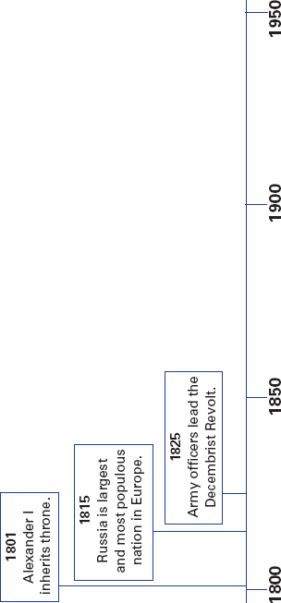

120

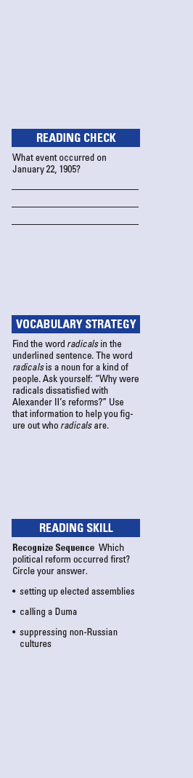
Name Class Date

By 1815, Russia was the largest nation in Europe. The Russian
colossus, or giant, had vast natural resources. Reformers
hoped to free the country from autocratic rule, economic back-
wardness, and social injustice. A rigid social structure, howev-
er, presented an obstacle to progress. Also, the tsars had ruled
with absolute power for centuries.
Alexander II became tsar during the Crimean War. His
reign followed the pattern of reform and repression of previous
tsars. When Russia lost the war, it showed the country’s back-
wardness and inefficiency. People demanded changes. The tsar
agreed to some reforms. He ordered the emancipation, or free-
dom, of serfs. He set up elected assemblies, called zemstvos.
Then he made legal reforms, which included trial by jury. How-
ever, these changes did not satisfy many Russians. As radicals
insisted on even greater changes and more reforms, the tsar
moved toward repression. This angered radicals. Terrorists
killed Alexander II in 1881. In response to his father’s death,
Alexander III brought back repressive rule. He suppressed the
cultures of non-Russian peoples. Official persecution fueled
pogroms, or violent mob attacks on Jewish people. Many Jews
left Russia and became refugees, seeking safety elsewhere.
Russia entered the industrialized age under Alexander III
and his son Nicholas II. However, industrialization caused
political and social problems to build. On Sunday, January 22,
1905, a peaceful protest calling for reforms turned deadly. The
tsar’s troops killed and wounded hundreds of people. Follow-
ing this “Bloody Sunday,” unrest exploded across Russia.
Nicholas was forced to make many reforms. He agreed to call a
Duma, or an elected national legislature. He also named Peter
Stolypin as prime minister. Stolypin recognized that Russia
needed reform. Unfortunately, the reforms he introduced were
too limited. By 1914, Russia was still an autocracy, but simmer-
ing with discontent.
Review Questions
1. What was the obstacle to progress in Russia in the 1800s?

2. What did Alexander III do in response to his father’s death?

121

