Name Class Date

Colonizers and the people they colonized often had different opinions about the new imperial-
ism. In the first excerpt, missionary-explorer Dr. David Livingstone (1813–1873) writes in his
diary about his feelings about working in Africa. In the second excerpt Basil Davidson, a mod-
ern expert on Africa, reports on some of the reactions of African leaders of the same period.
♦ As you read, think of some other possible points of view on both sides. Then, on a separate sheet of
paper, answer the questions that follow.

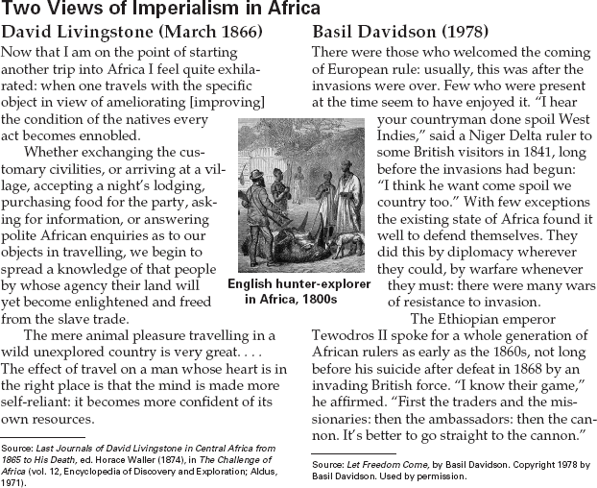

1. Why does Livingstone feel uplifted by the
thought of his coming trip to Africa?
2. How did Tewodros II describe the Europeans
who came to Africa? How did he respond?
3. Analyze Viewpoints Write a summary that
compares and contrasts the viewpoints of
Livingstone and Tewodros II on the goals of
Europeans in Africa.

70
Name Class Date

In 1859 Frenchman Ferdinand de Lesseps convinced the viceroy of Egypt, Muhammad Said
Pasha, to build a canal across the Isthmus of Suez. Although Lesseps promised the viceroy that
the canal would benefit Egypt, it was actually the European powers that reaped major benefits.
♦ As you read, consider the gulf between Lesseps’s promises in the first selection and the financial reality
in the second. Then, on a separate sheet of paper, answer the questions that follow.
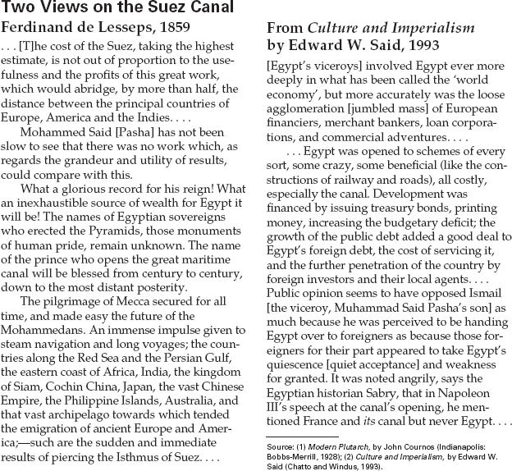

1. What were some promises Lesseps made
about the benefits of the canal?
2. According to Edward Said, who really con-
trolled the canal?
3. Predict Consequences Many Egyptians were
angry about the way foreigners were taking
advantage of the building of the canal. What
do you think happened to the relationship
between Egypt and the European powers?

72
Name Class Date

Imperialism brought many elements of British government and culture to India, but India’s
own ancient traditions remained strong. One gifted artist who tried to bridge the gap between
the two was Rabindranath Tagore, the first non-European writer to win the Nobel Prize for
Literature. ♦ As you read, think about how different cultures influence each other. Then, on a separate
sheet of paper, answer the questions that follow.
Rabindranath Tagore (1861–1941)

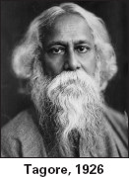
The life and work of Rabindranath Tagore
touched every element of Bengali* culture—
music, poetry, philosophy, and painting—and
are still influential today. He also helped
introduce that culture to people
beyond India.
Tagore was born in Calcutta
and, like many young men from
wealthy Indian families, went to
England briefly to study law. Other
members of the Tagore family were
well-known artists and philoso-
phers, and he grew up surrounded
by literature and music. He began
writing poetry in his teens and then
turned to short stories, novels, and
plays. At 19, when he wrote his first novel, he
was already famous in India.
After writing love poetry when he was
young, Tagore turned to religious and philo-
sophical writing. He also became one of the
country’s leading painters. Also a composer,
he blended folk and classical music styles in
songs known as Rabindra Sangeet. These songs
became as well known as his poetry and are
still sung throughout South Asia, wherever
people speak Bengali. As a public figure,
Tagore was greatly admired and revered, and
huge crowds flocked to hear him speak in
Calcutta.
In 1891 he settled in Shileida at his father’s
estate. The natural beauty of the countryside
and the Ganges River became important ele-
ments in his work. He also came to know the
rural people, whose lives he
described in short stories.
Tagore’s father, a respected
philosopher, had founded a retreat
in the country called Santiniketan
(Abode of Peace). In 1901 Tagore
established a school there to teach a
blend of Eastern and Western cul-
tures and thought. The school
expanded into an international uni-
versity in 1921. Tagore himself also
traveled and lectured throughout
Europe, Asia, and the Americas.
Tagore wrote primarily in Bengali, using
its rhythm and meter. He also translated
many of his own works into English. In 1913
he won the Nobel Prize for Literature for the
English version of Gitanjali (“Song Offerings”),
a collection of short meditations.
King George V knighted Tagore in 1915.
Tagore gave up the honor in 1919 after British
troops fired on a crowd in Amritsar, killing
nearly 400 Indians.

*relating to the people and language of Bengal, in eastern India

1. In what different ways did Rabindranath
Tagore influence Indian culture?
2. How did Tagore try to increase links between Indian and Western culture?
3. Make Comparisons Tagore had tremendous influence on so many aspects of Indian culture. Do you think one person could have this type of widespread influence on today’s
American culture? Explain your answer.

Name Class Date

From the mid-1800s, Chinese officials disagreed over the need to adopt Western ways. Chang
Chi-tung was a conservative official and scholar. While opposing the establishment of democ-
racy in China, Chang argued for many reforms, especially in education. In the 1898 piece below,
Chang expresses the importance of having a solid foundation of Chinese knowledge before
studying Western ideas. ♦ As you read the selection, note how Chang opposed many Western ideas.
Then, on a separate sheet of paper, answer the questions that follow.
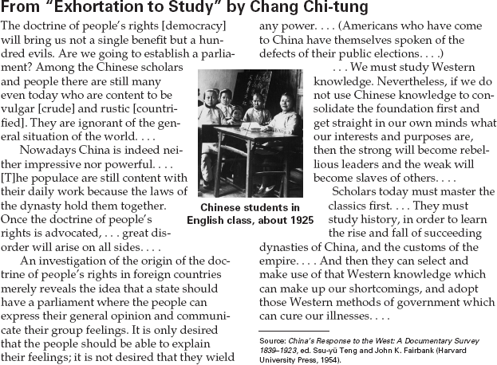

1. What are Chang’s principal objections to democracy?
2. While Chang advocates educational reform by studying Western knowledge,
3. Analyze Information Which of Chang’s arguments do you find most persuasive? Why?

how far does he think this reform should
be taken?

