Name Class Date

Focus Question: How did Western nations come to dominate much of
the world in the late 1800s?
As you read this section in your textbook, complete the chart below showing the
multiple causes of imperialism in the 1800s. Some items have been completed for you.

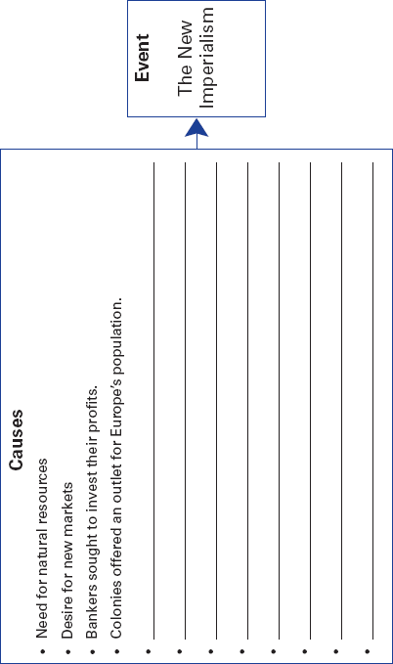

130
Name Class Date

Many Western countries built overseas empires in the late
1800s. This expansion is called imperialism. It is the domina-
tion by one country of another country or region. In the 1800s
Europeans began an aggressive expansion called the “new
imperialism.” The new imperialism had many causes. The
Industrial Revolution was one. Manufacturers needed natural
resources such as rubber and petroleum. They needed new
markets to sell their goods. Colonies provided a place for
Europe’s growing population to live, too.
Nationalism played an important role, as well. Europeans
felt that ruling a global empire increased a nation’s prestige and
influence. If one country began claiming Asian or African lands,
rival nations would move in to claim nearby lands. Many in
Europe were concerned about people overseas; they believed
they had a duty to spread Western medicine, law, and religion.
But there was also a growing sense that Europeans were racially
superior to non-Westerners. Many Westerners used Social
Darwinism to justify dominating other societies. As a result, mil-
lions of non-Westerners were robbed of their cultural heritage.
Africans and Asians strongly resisted Western expansion.
Some people fought the invaders, but the Europeans had
superior weapons and technology, such as machine guns, the
telegraph, and riverboats. Others tried to strengthen their
societies by reforming their own religious traditions. Many
Western-educated Africans and Asians organized nationalist
movements to expel the imperialists.
The imperial powers had several ways to control colonies.
The French practiced direct rule. They sent officials from France
to run the colony. The British often used indirect rule, governing
through local rulers. In a protectorate, local rulers were left in
place but were expected to follow the advice of Europeans. In a
sphere of influence, an outside power claimed exclusive
investment or trading privileges, but did not rule the area.
Europeans did this to prevent conflicts among themselves.
Review Questions
1. What kinds of technology aided imperialism?

2. How is a protectorate different from a sphere of influence?

131
Name Class Date

Focus Question: How did imperialist European powers claim control
over most of Africa by the end of the 1800s?
As you read this section in your textbook, complete the chart below by identifying the
causes and effects of the partition of Africa by European nations. Some items have
been completed for you.
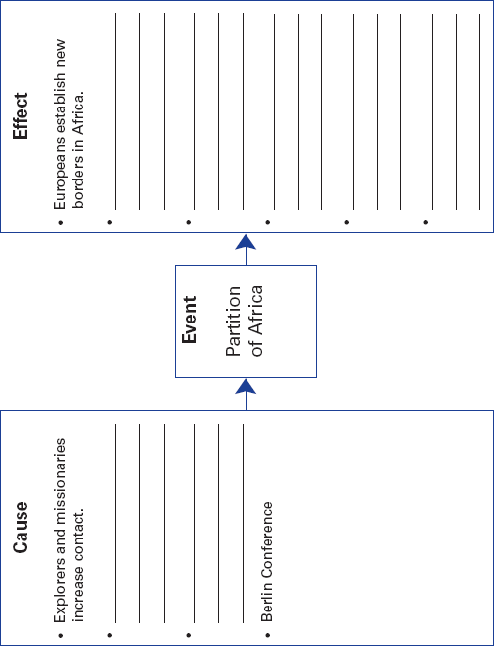

132
Name Class Date

Before the 1800s, the Ottoman empire ruled much of North
Africa. In West Africa, Usman dan Fodio set up a successful
Islamic state inspiring other Muslim reform movements. Islam
and trade influenced East Africa. In southern Africa, the Zulus
emerged as a major force. They were led by Shaka, a ruthless
and brilliant leader. His conquests set off huge migrations of
conquered people to other areas and caused new wars.
European contact with Africans increased when European
explorers pushed into the interior. Missionaries followed the
explorers. They built schools, churches, and medical clinics.
However, they took a paternalistic view of Africans, treating
them like children. One explorer and missionary, Dr. David
Livingstone, spent so many years in Central Africa that the
journalist Henry Stanley was sent to find him.
About 1871, King Leopold II of Belgium hired Stanley to
arrange trade treaties with African leaders. Leopold’s interest
caused Britain, France, and Germany to join in a scramble for
African land. To stop conflict, Europeans met in Berlin to divide
up the continent of Africa for themselves. As the years passed,
Europeans took more and more of Africa’s resources, and rarely
allowed Africans any role in government. When gold and dia-
monds were discovered in southern Africa, the British fought
the Boer War. The Boers were descendents of Dutch settlers.
Africans tried to resist European imperialism. Samori
Touré fought French forces in West Africa. Yaa Asantewaa was
an Asante queen who led the fight against the British. Another
female leader was Nehanda of the Shona in Zimbabwe. Most
efforts failed, except in Ethiopia. Earlier, Ethiopia had been
divided up among rival princes who then ruled their own
domains. However, Menelik II modernized his country. His
army fought the Italians. The nation remained independent.
During this time, a Western-educated, upper-class African
elite developed. By the early 1900s, African nationalists had
begun to work for independence.
Review Questions
1. What did King Leopold hire Stanley to do?

2. Why did Europeans meet in Berlin?

133
Name Class Date

Focus Question: How did European nations extend their power into
Muslim regions of the world?
As you read this section in your textbook, complete the concept web below to
understand the effects of European imperialism on Muslim regions. Some items have
been completed for you.
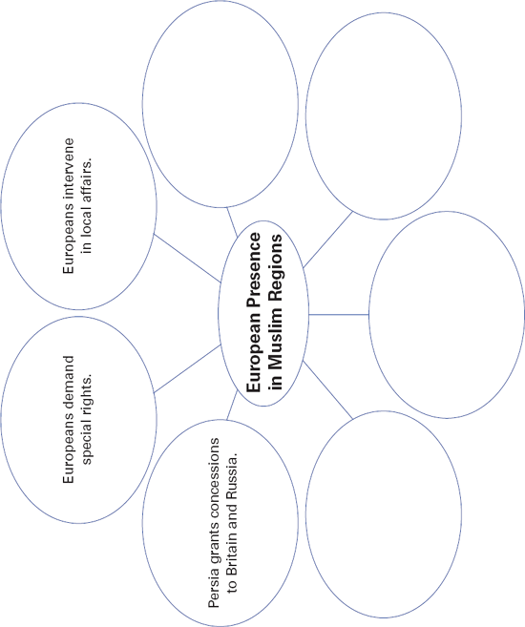

134
Name Class Date

In the 1500s, there were three great Muslim empires—the
Ottomans in the Middle East, the Safavids in Persia, and the
Mughals in India. By the 1700s, all three were in decline due to
corruption and discontent. In response, Muslim reform move-
ments arose. They stressed spiritual devotion and strict rules
on how to act. Some also opposed foreign expansion in Mus-
lim areas. For example, in the Sudan, Muhammad Ahmad said
that he was the Mahdi, the long-awaited savior of the faith.
The Mahdi and his followers fiercely fought British expansion.
At its height, the Ottoman empire extended across parts of
North Africa, Southeastern Europe, and the Middle East.
When ideas of nationalism spread from Western Europe, peo-
ple within the empire began to rebel. Ambitious pashas want-
ed more power. Some leaders looked to the West for ideas on
reforming the government and its rigid rules. In the early
1700s, they reorganized the bureaucracy. Repressive sultans
usually rejected reform. Another problem was tension between
Turkish nationalists and minority groups. This led to a brutal
genocide of Christian Armenians when Turks thought that
Armenians were supporting Russia against Turkey.
In the early 1800s, Egypt was a semi-independent province
of the Ottoman empire. Muhammad Ali is sometimes called
the “father of modern Egypt” because he introduced a number
of political and economic reforms. He conquered the neighbor-
ing lands of Arabia, Syria, and Sudan. Before he died in 1849,
he had set Egypt on the road to becoming a major Middle
Eastern power. His successors lacked his skills, however. In
1882, Egypt became a protectorate of Britain.
Like the Ottoman empire, Persia—now Iran—faced major
challenges. Foreign nations, especially Russia and Britain,
wanted to control Iran’s oil fields. They were granted special
rights called concessions, and even sent in troops to protect
their interests. These actions outraged Iranian nationalists.
Review Questions
1. Why did Muslim reform movements arise?

2. Why is Muhammad Ali sometimes called the “father of
modern Egypt”?

135
Name Class Date

Focus Question: How did Britain gradually extend its control over most
of India despite opposition?
As you read this section in your textbook, complete the flowchart below to identify the
causes and effects of British colonial rule in India. Some items have been completed
for you.
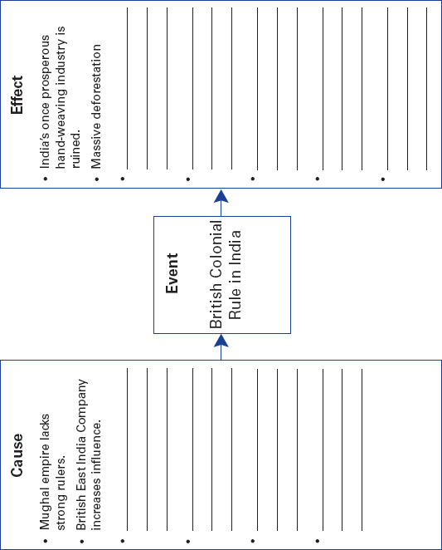

136
Name Class Date

Mughal rulers once had a powerful Muslim empire in India.
The British East India Company had trading rights on the edges
of the empire. The main goal of the East India Company was to
make money. As Mughal power declined, the East India
Company gained power. The British were able to conquer India
because Indians were not able to unite against the British.
The British felt that Western religion and culture was more
advanced than Indian religions and culture. In the 1850s, the
East India Company made several unpopular moves. The most
serious caused the Sepoy Rebellion. Indian soldiers, or sepoys,
were told to bite off the tips of their rifle cartridges. This
caused a rebellion because the cartridges were greased with
animal fat, violating local religious beliefs. The British crushed
the revolt, killing thousands of Indians.
After the rebellion, Parliament ended the rule of the East
India Company. Instead, a British viceroy governed India in
the name of the monarch. In this way, the overall British econ-
omy could benefit from trade with India. However, this trade
favored the British. Also, although the British built railroads
and telegraph networks, they ruined India’s hand-weaving
industry. Encouraging Indian farmers to grow cash crops led
to deforestation and famines.
Some educated Indians wanted India to become more
modern. Others felt they should stay with their own Hindu or
Muslim cultures. In the early 1800s, Ram Mohun Roy combined
both views. Roy condemned child marriage and sati, which
called for a widow to throw herself on her husband’s funeral
fire. He opposed purdah, or the isolation of women. He also set
up educational societies to help revive pride in Indian culture.
Most British felt that Western-educated Indians would be happy
with British rule. Instead, Indian nationalists formed the Indian
National Congress in 1885 and began pressing for self-rule.
Review Questions
1. How were the British able to conquer India?

2. What caused the Sepoy Rebellion?

137
Name Class Date

Focus Question: How did Western powers use diplomacy and war to
gain power in Qing China?
As you read this section in your textbook, complete the chart below by listing the
multiple causes of the decline of Qing China. Some items have been completed for you.
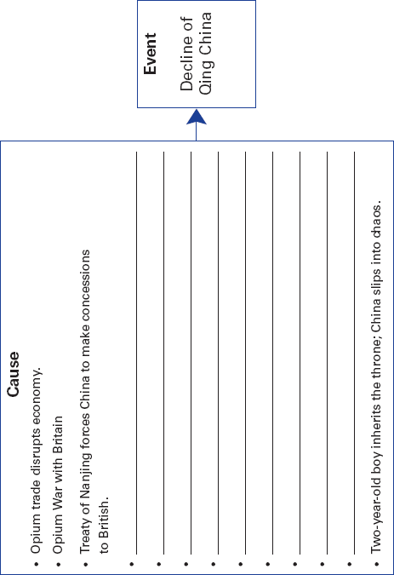

138
Name Class Date

For centuries, China had a favorable balance of trade, because
of a trade surplus. Westerners had a trade deficit with China,
buying more from the Chinese than they sold to them. Then the
British began trading opium grown in India in exchange for
Chinese tea. The Chinese asked Britain to stop this drug trade.
The British refused, and this led to the Opium War in 1839.
Without modern weapons and fighting methods, the Chinese
were easily defeated. Under the Treaty of Nanjing, which ended
the war, Britain received a huge indemnity and British citizens
gained the right of extraterritoriality. Afterward, France, Russia,
and the United States each made specific demands on China.
China felt pressure to sign treaties stipulating the opening of
more ports and allowing Christian missionaries into China.
China had other problems too. Peasants hated the corrupt
Qing government. Their rebellion, known as the Taiping
Rebellion, almost toppled the Qing dynasty. Another problem
was that educated Chinese did not agree about modernizing.
Some felt Western ideas and technology threatened
Confucianism. Reformers who wanted to adopt Western ways
did not have government support.
Meanwhile, China’s defeat in the Sino-Japanese War of
1894 encouraged European nations to carve out spheres of
influence in China. The United States feared that America
might be shut out. The United States called for an Open Door
Policy, making trade in China open to everyone. Concerned
that China’s problems were due to not modernizing, the
emperor Guang Xu launched the Hundred Days of Reform in
1898. However, conservatives imprisoned the emperor.
Many Chinese were angry about the presence of foreigners.
Some formed a secret group known to Westerners as the
Boxers. A group known as the Boxers tried to kill foreigners in
the Boxer Uprising in 1900. Although the Boxers failed, nation-
alism increased. Reformers began calling for a republic. One of
them, Sun Yixian, became president of the new Chinese repub-
lic when the Qing dynasty fell in 1911.
Review Questions
1. What caused the Opium War?

2. What caused the Boxer Rebellion?

139

