Name Class Date

Many young men who went to war with high ideals of patriotism soon became oppo-
nents of war. In these poems, two young British soldier-poets respond to their war
experience. Brooke, a handsome athlete who was already a well-known poet, died
early in the war. Owen, a decorated hero, was killed in action a week before the war
ended. The title of his poem comes from a Latin phrase meaning “It is sweet and right
to die for one’s country.” ♦ As you read, think about each writer’s reactions. Then, on a
separate sheet of paper, answer the questions that follow.
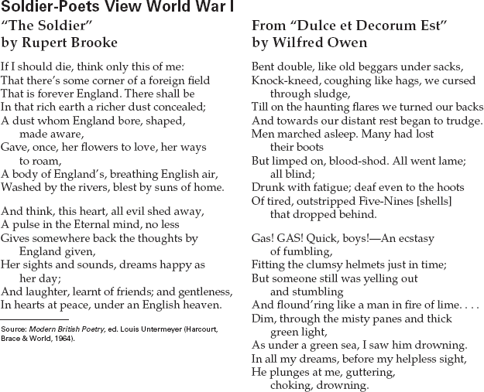

1. What does Brooke remember about his life
in England?
2. In Owen’s poem, what weapon of war do the
soldiers encounter in the second verse? What
do they do? What happens to one of them?
3. Make Comparisons Compare the two pic-
tures of war—and of dying in war—that
these poets give. If Brooke had lived long
enough to serve in trench war, do you think
he might have written differently?

11
Name Class Date

In terms of human lives, World War I was extremely brutal and costly. One young
German soldier killed in 1914 was the son of the artist Kaethe Kollwitz, who is
famous for her strong woodblock prints and sculptures showing human suffering.
In her diary of the war years, Kollwitz reflected on her son’s death and the wasteful-
ness of war. ♦ As you read the excerpts, think about how personal experience influences an
artist. Then, on a separate sheet of paper, answer the questions that follow.

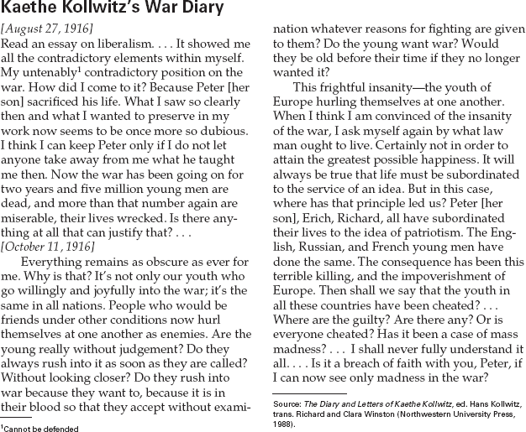

1. What idea does Kollwitz say motivated her
son and other young Germans to rush to war?
2. How do the actions of Kollwitz’s son compare
to those of young men in other countries?
- Recognize Ideologies What conflicting feel-
ings does Kollwitz have about war and
about patriotism?
- Activity Write a journal entry describing
your feelings about war and patriotism.
Compare your feelings with Kollwitz’s.

Name Class Date

Woodrow Wilson led the United States into World War I, “to make the world safe for
democracy” and to fight a “war to end war.” Although many in his own country did
not share his idealism, his concept of an international peace organization lives on
today in the United Nations. ♦ As you read, note aspects of Wilson’s personality that
influenced his politics. Then, on a separate sheet of paper, answer the questions that follow.

(Thomas) Woodrow Wilson (1856–1924)
As a child in the South, Woodrow Wilson
witnessed the total destruction caused by the
Civil War. Because of this, he understood how
war could ruin a country and devastate its
people. These early impressions never left him.
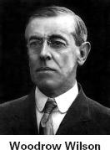
Wilson began his adult life with a law
degree, but eventually turned to the
study of political science, earning a
Ph.D. in the subject. He then began
a long career as a college professor,
married, and had three daughters.
In 1902, he was invited to
become the president of Princeton
University. After his reforms on
campus met with a mixed recep-
tion, he was happy to accept the
Democratic Party’s nomination for
governor of New Jersey. However,
he refused to take direction from
the conservative political bosses who had put
him in office. His independence and progres-
sive reforms gained him national attention. In
1912, he became the Democratic candidate for
president, running against William Howard
Taft and Theodore Roosevelt. Those two
Republicans split the vote enough to give
Wilson the victory.
In his first term, Wilson oversaw several
major reforms, such as anti-trust laws, an
8-hour day for railroad workers, and an end
to child labor. In 1916, he was re-elected
based on these reforms and his promise to
keep the United States out of World War I.
However, by 1917, Wilson was convinced
that the United States had a role to play
in the war. He requested and got a declara-
tion of war on Germany. In a
speech to Congress, Wilson out-
lined the American goals, his
Fourteen Points.
When the war ended, Wilson
attended the Paris Peace Confer-
ence to put forward the Fourteen
Points, and to try to forge an
enduring peace. He met with lim-
ited success, but did get the League
of Nations included in the Treaty of
Versailles. However, when Wilson
presented the treaty for ratification
by the U.S. Senate, it failed to pass by seven
votes.
Wilson vowed he would personally build
support among Americans for the treaty. He
traveled across the nation explaining the
importance of the treaty. However, this gruel-
ing effort exhausted him, and he suffered a
debilitating stroke in October 1919. Although
he partially recovered, his health was perma-
nently ruined. He died in retirement a little
over four years later.

1. What early experience led Wilson to be
anti-war?
2. How did Wilson become president of the
United States?
- Draw Conclusions Wilson did not have a
great deal of political experience before he
became president. Do you think this helped
or hurt his presidency?

9

Name Class Date

The story below is based on events from the author’s own life, including her near-
death from influenza during World War I. The story centers on Miranda, a young
woman newspaper columnist who also nearly dies from influenza during the war.
In an over-crowded hospital, suffering from a high fever she begins to hallucinate or
dream about her kindly doctor, who happens to have a German name. ♦ As you read,
think about what it might have been like to live during both the first global war and a deadly
pandemic. Then, on a separate sheet of paper, answer the questions that follow.
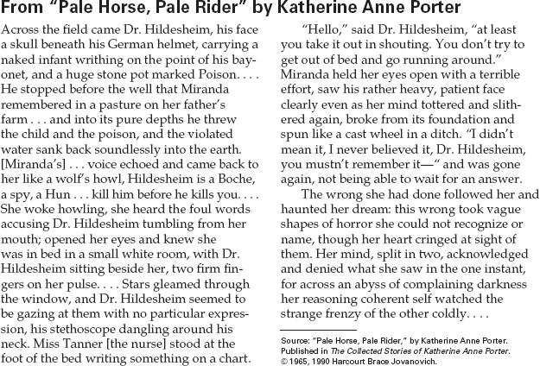

1. Why does Miranda have that particular
vision of Dr. Hildesheim?
2. How does the doctor respond to what he
hears Miranda say?
3. Draw Inferences Miranda’s vision is based
on famous images from American propa-
ganda posters of the time. Why might Porter
have included images such as these in her
story?
4. Test Conclusions The title of the story is
from the biblical book of Revelation in which
death appears at the end of the world as a
pale rider on a pale horse. Why do you think
Porter chose this title for her story?

12

