Name Class Date

Focus Question: Why and how did World War I begin in 1914?
As you read this section in your textbook, complete the following chart to summarize
the events that led to the outbreak of World War I. Some items have been completed
for you.
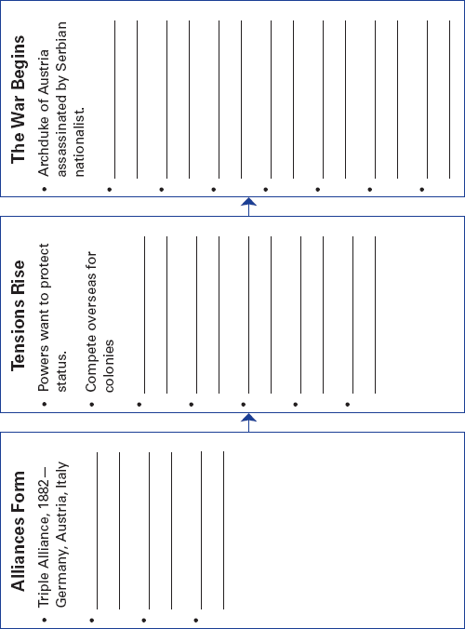

148
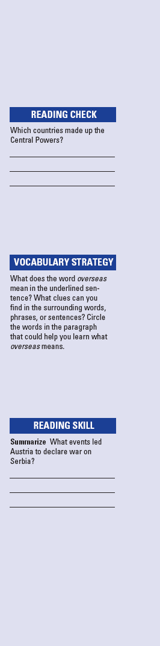
Name Class Date

Although powerful forces were pushing Europe towards war,
the great powers had made non-binding agreements, called
ententes, to try to keep the peace. The Triple Alliance was
made up of Germany, Austria-Hungary, and Italy. Russia,
France, and Britain made up the Triple Entente. During World
War I, Germany and Austria fought on the same side. They
were called the Central Powers. Russia, France, and Britain
were known as the Allies.
In the period before the war, European powers competed.
They wanted to protect their status. Overseas rivalries divided
them. They fought for new colonies in Africa and elsewhere.
They began to build up their armies and navies. The rise of
militarism helped to feed this arms race.
Nationalism also caused tensions to grow. Germans were
proud of their military and economic power. The French
wanted Alsace and Lorraine back from Germany. Pan-Slavism
led Russia to support fellow Slavs in Serbia. Austria and
Ottoman Turkey were afraid that they would lose territory,
especially in the Balkans. Soon, unrest made that region a
“powder keg.” Then, a Serbian nationalist shot to death the
heir to the Austrian throne at Sarajevo, Bosnia.
Some Austrian leaders saw this as a chance to crush Serbia.
They sent Serbia an ultimatum, or set of demands, which
Serbia partly refused to follow. Austria, with Germany’s full
support, declared war on Serbia in July 1914.
Soon, the network of agreements drew other great powers
into the fight. Russia began to mobilize its army to support
Serbia. Germany then declared war on Russia. France said it
would keep to its treaty with Russia, so Germany declared war
on France, too. When Germany invaded Belgium to get to
France, it ended Belgium’s neutrality. This caused Britain to
declare war on Germany. World War I had begun.
Review Questions
1. How did the network of European agreements cause World
War I to start?

2. What act caused Britain to declare war?

149
Name Class Date

Focus Question: How and where was World War I fought?
A. As you read “Stalemate on the Western Front,” “Battle on Other European
Fronts,” and “War Around the World,” record important details about World
War I events in the flowchart below. Some items have been completed for you.
Eastern Front
Battle lines shifted.

Elsewhere in Europe
Bulgaria joined the Central
Powers and helped defeat its
old Balkan rival Serbia.

Ottoman Empire
Joined the Central Powers

Western Front
Stalemate
First battle of the Marne
prevented a quick German victory.
Soldiers fought from trenches.

Colonies
European colonies were drawn
into the war.

B. As you read “Technology of Modern Warfare,” complete the following concept
web to summarize information about the technology of World War I. Some items
have been completed for you.

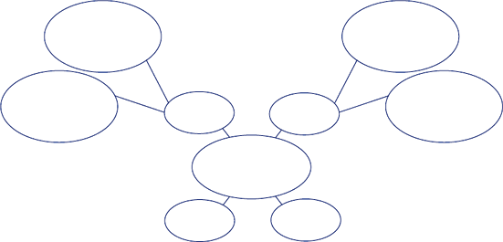
Airplanes

Aircraft
Technology of
World War I
Tanks
Guns

Poison
Gas

150
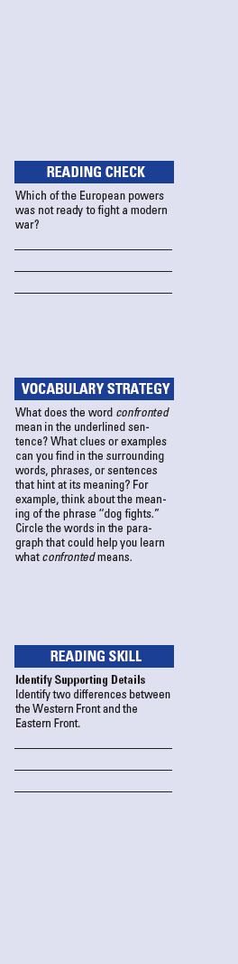
Name Class Date

World War I was the largest conflict in history up to that time.
Millions of French, British, Russian, and German soldiers went
to battle. Germany wanted to defeat France quickly, but
Belgian forces resisted Germany’s advance. Both sides dug deep
trenches on the battlefront to protect their armies from enemy
fire. This conflict on the Western Front turned into a long,
deadly stalemate, or deadlock that neither side could break.
New technology made World War I different from earlier
wars. Modern weapons were able to kill more soldiers than ever
before. In 1915, first Germany then the Allies began using poi-
son gas. New machines like tanks, airplanes, and submarines
were used in this war. In 1915, Germany flew zeppelins to
bomb the English coast. Both sides equipped airplanes with
machine guns. Pilots known as “flying aces” confronted each
other in the skies. However, their “dog fights” had little effect
on the ground war. German submarines called U-boats attacked
Allied ships. To defend against them, the Allies organized
convoys, or groups of merchant ships protected by warships.
Battle lines shifted back and forth on Europe’s Eastern
Front. War deaths were higher than on the Western Front.
Russia was not ready to fight a modern war. When pushing
into eastern Germany, Russian armies were badly defeated. In
1915, Italy declared war on Austria-Hungary and Germany. In
1917, the Austrians and Germans attacked the Italians.
Although most of the fighting took place in Europe, World
War I was a global conflict. Japan used the war to seize German
outposts in China and islands in the Pacific. The Ottoman
empire joined the Central Powers. Its strategic location enabled
it to cut off Allied supplies to Russia through the Dardanelles,
a vital strait. The Ottoman Turks were hard hit in the Middle
East. Arab nationalists rebelled against their rule. The British
sent T.E. Lawrence, or Lawrence of Arabia, to aid them.
European colonies in Africa and Asia were also drawn into
World War I.
Review Questions
1. Why did a stalemate develop on the Western Front?

2. What caused the great number of deaths during World War I?

151
Name Class Date

Focus Question: How did the Allies win World War I?
As you read this section in your textbook, complete the following outline to
summarize the content of this section. Some items have been completed for you.
I. Waging total war
A. Economies committed to war production.
1. Conscription
2. Rationing
3. Price controls
B. Economic warfare
1.
2.
3.
C. Propaganda war
1.
2.
3.
D. Women join war effort.
1.
2.
3.
II. Morale collapses.
A. War fatigue
1.
2.
3.
B.
1.
2.
3.

(Outline continues on the next page.)

52
Name Class Date

(Continued from page 152)
III. United States declares war.
A.
1.
2.
3.
B.
1.
2.
3.
C.
1.
2.
3.
IV
A.
B.
C.

153
Name _________________ Class Date

World War I was the first total war. Nations put all their
resources into the war effort. Both sides set up systems to
recruit, arm, transport, and supply their armies. Nations set up
military conscription, or “the draft.” This required all young
men to be ready to fight. Women played an important role, too.
They took over the jobs of millions of men who had left to fight.
International law allowed wartime blockades to seize
contraband, such as weapons or other illegal goods. British
blockades, however, kept ships from carrying other supplies,
such as food, in and out of Germany. In response, German
U-boats torpedoed the British passenger liner the Lusitania.
Both sides used propaganda to control public opinion. They
printed tales of atrocities. Some were true and others were not.
After a time, war fatigue set in. Long casualty lists, food
shortages, and the failure to win led to calls for peace. The
morale of troops and civilians plunged. In Russia, stories of
unfit generals and corruption eroded public confidence and
led to revolution.
In 1917, the United States joined the fight by declaring war
on Germany. Many factors led to this decision. Germany kept
up its submarine attacks. Also, many Americans supported the
Allies because of cultural ties. By 1918, about two million fresh
American soldiers had joined the tired Allied troops. Earlier in
that year, President Wilson had issued his Fourteen Points.
This list of terms for ending this and future wars included
self-determination for the peoples of Eastern Europe.
In March of 1918, a final showdown on the Western Front
began. American troops and Allies drove back German forces.
German generals told the kaiser that the war could not be won.
The kaiser stepped down and the new German government
asked for an armistice to end the fighting. At 11 A.M. on
November 11, 1918, World War I came to an end.
Review Questions
1. What effect did years of war have on morale?

2. What are two reasons why the United States entered the war?

Name Class Date

Focus Question: What factors influenced the peace treaties that ended
World War I and how did people react to the treaties?
A. As you read “The Costs of War,” complete this concept web to summarize the
costs of World War I. Some items have been completed for you.
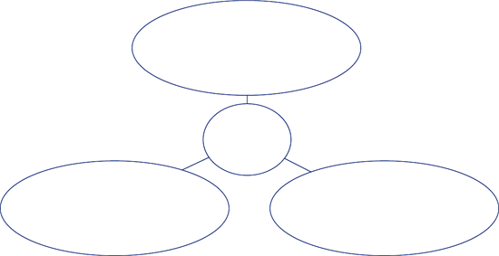
The Costs
of War
Millions of soldiers
dead or wounded

B. As you read “The Paris Peace Conference,” “The Treaty of Versailles,” and
“Outcome of the Peace Settlements,” use this table to categorize issues and problems
that resulted from postwar agreements. Some items have been completed for you.
Because of the treaty, the
new German Republic had to
make large payments to pay
for damage caused by the war.
War Debt
Fear of German
Strength
Nationalism
League of Nations
Problems
Treaty Settlement
Colonies and Other
Non-European
Territories
Issue

These payments would
hurt an already damaged
German economy.

The treaty limited the size of
the German military.

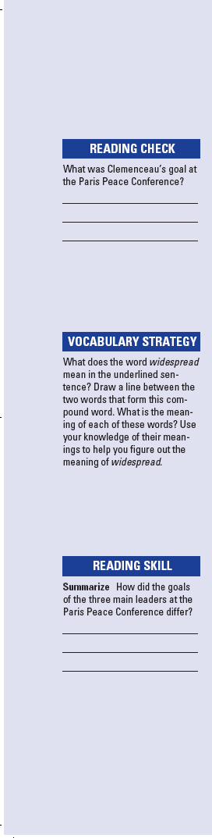
155
Name Class Date

The costs of World War I were huge in several ways. There was
a great loss of life made worse by an influenza pandemic. In
addition, raising the money to cover war debts and to rebuild
homes, farms, factories and roads would create new economic
problems. The Allies blamed the war on the defeated nations
and demanded that they make reparations, or payments for
war damage. Governments had collapsed in Russia, Germany,
Austria-Hungary, and the Ottoman empire. Out of all the
chaos, political radicals dreamed of building a new social order.
At the Paris Peace Conference, the Allies decided the fate of
Europe, the former Ottoman empire, and colonies around the
world. The three main Allied leaders had different goals. British
Prime Minister David Lloyd George wanted money to rebuild
Britain. The French leader Georges Clemenceau wanted to
weaken Germany so that it could never threaten France again.
American President Wilson didn’t think that was the way to
build a lasting peace. Wilson insisted on creating a League of
Nations. The League, based on the idea of collective security,
would work as one group to keep peace for all nations.
In June 1919, the Allies ordered delegates of the new German
Republic to sign the Treaty of Versailles. The Germans were
upset that the treaty forced Germany to take the blame for caus-
ing the war, cut the size of Germany’s military, and burdened
the German economy with war reparations.
The Allies then drew up treaties with the other Central
Powers. Like the Treaty of Versailles, these treaties left
widespread dissatisfaction. Many nations felt betrayed by the
peacemakers—especially people in colonies who had hoped
for an end to imperial rule. Outside Europe, the Allies added
to their overseas empires by creating a system of mandates.
However, the Paris Peace Conference did offer one ray of hope
by starting the League of Nations. Unfortunately, the failure of
the United States to support the League weakened it.
Review Questions
1. What were the high costs of World War I?

2. Why were the leaders of the new German Republic upset
over the Treaty of Versailles?

156
Name Class Date

Focus Question: How did two revolutions and a civil war bring about
Communist control of Russia?
As you read this section in your textbook, fill in the following timeline with dates and
facts about the series of events that led to Communist control of Russia. Some items
have been included for you. Then write two sentences summarizing the information in
the timeline.
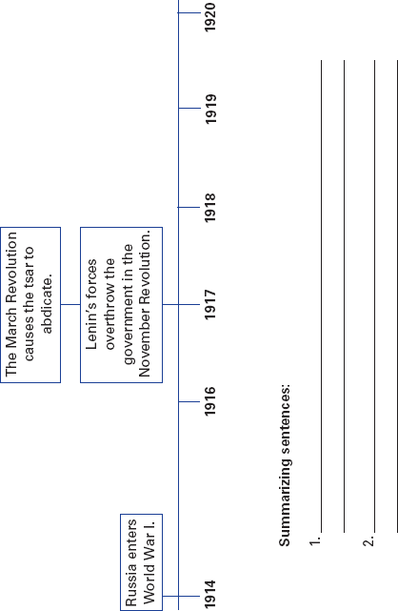

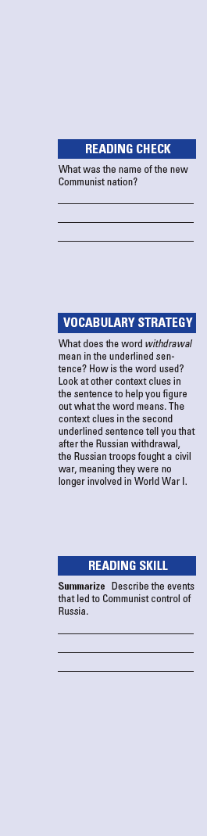
157
Name Class Date

By the early 1900s Russia had many problems. Tsar Nicholas II
resisted change. Marxists tried to start a revolution among the
proletariat factory workers and urban wage earners. World
War I strained Russian resources. By March 1917, disasters on
the battlefield and shortages at home caused the tsar to give up
his power. Politicians set up a temporary government. Mean-
while, revolutionary socialists set up their own councils of
workers and soldiers called soviets. These radical socialists,
called Bolsheviks, were led by V. I. Lenin. Lenin believed
only revolution could bring change. The Russian people were
hungry and tired of war. Lenin promised them “Peace, Land,
and Bread.” In November 1917, the Bolsheviks, renamed
Communists, overthrew the government and seized power.
After the Bolshevik Revolution, events in Russia led to the
nation’s withdrawal from World War I. After the withdrawal,
civil war raged for three years between the Communist “Reds”
and the “White” armies of tsarist imperial officers. The
Russians now fought only among themselves. The Communists
shot the former tsar and his family. They organized the Cheka,
a brutal secret police force. Red Army officers were kept under
the close watch of commissars—Communist Party officials.
The Reds’ position in the center of Russia gave them an advan-
tage. They defeated the White armies, and the civil war ended.
Lenin had to rebuild the government and economy. The
new nation was called the Union of Soviet Socialist Republics
(USSR), or Soviet Union. The new Communist constitution set
up an elected legislature. All political power, resources, and
means of production would belong to workers and peasants.
In reality, however, the Communist Party, not the people, had
all the power. However, Lenin allowed some features of capi-
talism that helped the Soviet economy recover from the wars.
After Lenin’s death, Joseph Stalin took ruthless steps to win
total power over the country.
Review Questions
1. Why did the tsar give up power?

2. Why do you think Lenin’s revolutionary slogan—“Peace,
Land, and Bread”—was popular with the Russian people?

