Name Class Date

In September 1938, Neville Chamberlain, Britain’s prime minister, met with the leaders of
Germany, Italy, and France. He wanted to find a peaceful compromise with Hitler. The resulting
document, the Munich Agreement, gave Hitler everything he asked for. While Chamberlain felt
he had achieved “peace for our time,” some people, like future prime minister Winston Churchill,
were unhappy with the agreement. ♦ As you read the speeches, keep in mind each man’s response to the
thought of war with Germany. Then, on a separate sheet of paper, answer the questions that follow.

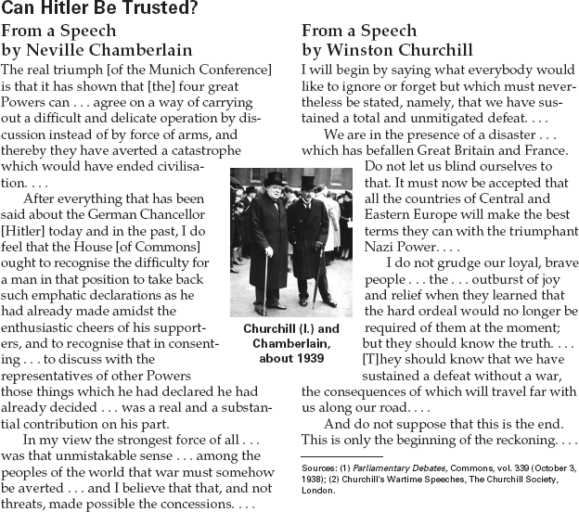

1. What do you think the other leaders hoped
to accomplish by giving in to Hitler?
2. Why does Winston Churchill consider this
decision a disaster?
3. Analyze Information Which man do you feel
made the stronger argument? Explain.

Name Class Date

Elie Wiesel and his family were Jews living in Hungary when the Germans invaded in 1944. The
Wiesels were sent to the concentration camp at Auschwitz when Wiesel was 15. After the war,
Wiesel waited ten years before writing about his experiences in Night. In the excerpt, Wiesel
recalls his first night in the camp. ♦ As you read, notice how people reacted to the horrors of the concen-
tration camp. Then, on a separate sheet of paper, answer the questions that follow.

From Night by Elie Wiesel
The barrack we had been assigned to was very
long. On the roof, a few bluish skylights. I
thought: This is what the antechamber of hell
must look like. So many crazed men, so much
shouting, so much brutality.
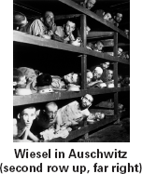
Dozens of inmates were there to receive us,
sticks in hand, striking anywhere, anyone,
without reason. The orders came:
“Strip! Hurry up! Raus! Hold on
only to your belt and your shoes . . .”
Our clothes were to be thrown
on the floor at the back of the bar-
rack. There was a pile there already.
New suits, old ones, torn overcoats,
rags. For us it meant true equality;
nakedness. We trembled in the cold.
A few SS officers wandered
through the room, looking for strong
men. If vigor was that appreci-
ated, perhaps one should try to
appear sturdy? My father thought
the opposite. Better not to draw attention. (We
later found out that he had been right. Those
who were selected that day were incorporated
into the Sonder-Kommando, the Kommando
working in the crematoria. Bela Katz, the son of
an important merchant in my town, had
arrived in Birkenau with the first transport, one
week ahead of us. When he found out that we
were there, he succeeded in slipping us a note.
He told us that having been chosen because of
his strength, he had been forced to place his
father’s own body into the furnace.)
The blows continued to rain on us.:
“To the barber!”
Belt and shoes in hand. I let myself be dragged
along to the barbers. Their
clippers tore out our hair, shaved every hair on
our bodies. My head was buzzing; the same
thought surfacing over and over: not to be sep-
arated from my father.
Freed from the barbers’ clutches,
we began to wander about the
crowd, finding friends, acquain-
tances. Every encounter filled us
with joy—yes, joy: Thank God! You
are still alive!
Some were crying. They used
whatever strength they had left to
cry. Why had they let themselves be
brought here? Why didn’t they die
in their beds? Their words were
interspersed with sobs.
Suddenly someone threw his
arms around me in a hug: Yehiel, the Sigheter
rebbe’s brother. He was weeping bitterly. I
thought he was crying with joy at still being
alive.
“Don’t cry, Yehiel.” I said. “Don’t waste
your tears . . .”
“Not cry? We’re on the threshold of death.
Soon, we shall be inside . . . Do you under-
stand? Inside. How could I not cry?”
I watched darkness fade through the
bluish skylights in the roof. I no longer was
afraid. I was overcome by fatigue.

1. What are the first things that happened to the
men in camp?
2. Identify Central Issues What evidence can
you find that Wiesel and the others still
retained their humanity in the face of brutal
treatment?
3. Determine Relevance Why is it important for
people today to read books like Night?

74
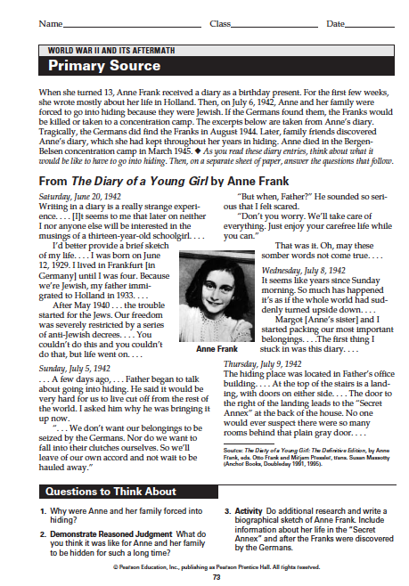
Name Class Date

On August 6, 1945, an American plane dropped an atomic bomb on the Japanese city of
Hiroshima. John Hersey’s classic book Hiroshima, written in 1946, vividly captures the aftermath
of the bombing. Hersey interviewed six residents who survived the blast, and in the book he
recounts their experiences. ♦ As you read this excerpt, think about the experience of people living in
Hiroshima when the United States dropped the bomb. Then, on a separate sheet of paper, answer the ques-
tions that follow.

From Hiroshima by John Hersey
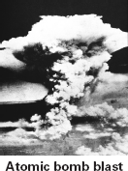
As Mrs. Nakamura stood watching her neigh-
bor, everything flashed whiter than any white
she had ever seen. . . . She had taken a single
step (the house was 1,350 yards, or three-
quarters of a mile, from the center
of the explosion) when something
picked her up and she seemed to fly
into the next room . . . pursued by
parts of her house.
. . . The debris did not cover her
deeply. She rose up and freed her-
self. She heard a child cry. . . . As
Mrs. Nakamura started frantically
to claw her way toward the baby,
she could see or hear nothing of her
other children. . . .
[Dr. Terufumi Sasaki, the Red Cross
Hospital surgeon] . . . was one step beyond an
open window when the light of the bomb was
reflected, like a gigantic photographic flash, in
the corridor. . . . Just then (the building was
1,650 yards from the center), the blast ripped
through the hospital. The glasses he was
wearing flew off his face . . . his Japanese slip-
pers zipped out from under his feet—but
otherwise, thanks to where he stood, he was
untouched.
. . . The hospital was in horrible confusion
. . . windows had blown in and cut people,
blood was spattered, . . . many of
the patients were running about
screaming, many more lay dead. . . .
Dr. Sasaki found himself the only
doctor in the hospital who was
unhurt.
Dr. Sasaki, who believed that
the enemy had hit only the build-
ing he was in, . . . got bandages and
began to bind the wounds of those
inside the hospital; while outside,
all over Hiroshima, maimed and
dying citizens turned their unsteady steps
toward the Red Cross Hospital. . . .
. . . Mr. Tanimoto saw an astonishing pan-
orama. . . . as much of Hiroshima as he could
see through the clouded air was giving off a
thick, dreadful miasma [poisonous fog]. . . .
He had thought of his wife and baby, his
church, his home, his parishioners, all of them
down in that awful murk. Once more he
began to run in fear—toward the city.

1. What was Mrs. Nakamura’s first response
when the atomic bomb went off?
2. How did Dr. Sasaki respond to the crisis?
What did Mr. Tanimoto do?
3. Demonstrate Reasoned Judgment When
President Truman decided to use the atomic
bomb against the Japanese, no one knew
exactly what the effects would be. Knowing
what we know now, do you think the atomic
bomb should ever be used again? Why or
why not?
4. Activity Research the bombing of Hiroshima.
Then, write a poem or story to represent the
effects of the bomb on the city and people.

75
Name Class Date

Harry Truman became president of the United States as World War II was ending. His decisions
helped shape the political and economic realities of the world in the second half of the twentieth
century. ♦ As you read, think about the personality traits that helped Truman act decisively as presi-
dent. Then, on a separate sheet of paper, answer the questions that follow.

Harry Truman (1884–1972)
Harry Truman was born in Missouri on May
8, 1884. He was the oldest of three children.
As a child, Truman was a good student, and
he grew up with a love for reading and music.
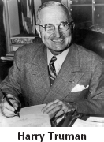
After graduating from high school in
1901, Truman briefly attended busi-
ness school. He also worked as a
bank clerk and on the family farm.
In 1917, the United States
entered World War I, and 32-year-
old Truman volunteered to join the
army. He served in France as the
captain of a U.S. field artillery unit
and won the loyalty of the men
under his command with his lead-
ership abilities. He returned home
in 1919, married his childhood
sweetheart, Bess, and opened a men’s clothing
store. When the business failed, a friend
encouraged Truman to enter politics. After
winning some local elections, he won a U.S.
Senate seat in 1934.
During Truman’s second term in the
Senate, he gained national recognition for
chairing a committee that looked into waste
and fraud in the U.S. military. It was this
work that brought him to the attention of
President Franklin Roosevelt, who asked
Truman to run as vice president in the 1944
election. When Roosevelt died 83 days into
his fourth term, Truman became president.
He was sworn in on April 12, 1945.
Truman oversaw the end of World War II
in Europe. While in Europe conferring with
the Allies, Truman received word of a suc-
cessful atomic bomb test by U.S. scientists.
Turning his attention to the war with Japan,
he demanded that the Japanese
surrender. When Japan refused,
Truman ordered the atomic bomb
be dropped on the Japanese cities
of Hiroshima and Nagasaki.
Shortly after the second bombing,
Japan surrendered.
Truman soon had to face the
beginning of the Cold War struggle
with the Soviet Union. In 1947, he
proclaimed the Truman Doctrine,
stating that the United States would
oppose Soviet aggression anywhere around
the globe.
Many political observers thought Truman
was going to lose his 1948 bid for reelection,
but Truman’s cross-country campaign fueled
an upset victory. Truman faced many chal-
lenges through his second term in office. He
dealt with rising tensions related to the Cold
War, including the Soviet blockade of Berlin in
1948 and the start of the Korean War in 1950.
After completing his second term, Truman
continued to be active in the Democratic Party,
and spent time campaigning for Democratic
candidates. In the mid-1960s, Truman’s health
declined rapidly. He died the day after
Christmas in 1972.

1. What were some of the jobs Truman held
before he became president?
2. What did Truman do to bring World War II to
a close?
3. Analyze Information How do you think
Truman’s personality and experience con-
tributed to decisions he made as president?

76

