Name Class Date
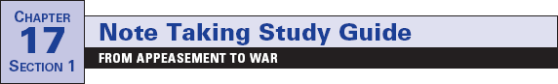

Focus Question: What events unfolded between Chamberlain’s
declaration of “peace in our time” and the outbreak of a world war?
A. As you read “Aggression Goes Unchecked” and “Spain Collapses into Civil
War,” complete the chart below to recognize the sequence of events that led to the
outbreak of World War II. Some items have been completed for you.
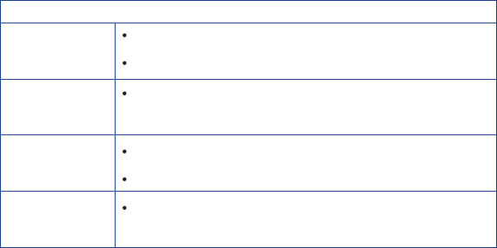
Acts of Aggression

Invasion of Manchuria, 1931

Japan

Italy

Germany
Buildup of German military

Spain

B. As you read “German Aggression Continues” and “Europe Plunges Toward
War,” complete the timetable below to recognize the sequence of German
aggression. One item has been entered for you.

German Aggression
March 1938
Anschluss, or union of Austria and Germany, occurs.

September 1938

March 1939

September 1939

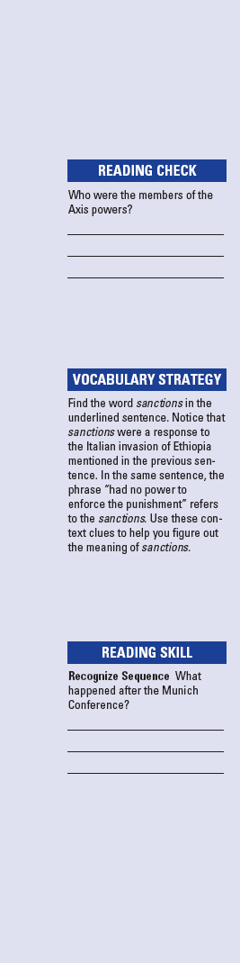
Name Class Date
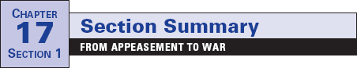

Throughout the 1930s, dictators took aggressive action.
However, they were met only by pleas for peace from Western
democracies. The dictators became even more aggressive. For
example, when the League of Nations condemned Japan’s
invasion of Manchuria in 1931, Japan just withdrew from the
League. Meanwhile, Mussolini invaded Ethiopia. The League
of Nations voted sanctions against Italy, but it had no power to
enforce the punishment. Hitler, too, defied the Western democ-
racies and the conditions of the Versailles treaty by building
up the German military. He also sent troops into the
Rhineland. The Western democracies denounced Hitler, but
adopted a policy of appeasement. Appeasement developed for
a number of reasons, including widespread pacifism. The
United States passed the Neutrality Acts at this time. The goal
was to avoid war, not prevent it. Germany, Italy, and Japan
saw the Western democracies as weak. These three nations
formed an alliance known as the Axis powers.
In Spain, Francisco Franco led a revolt against the new
Spanish government. This began a civil war in which Hitler
and Mussolini supported Franco, their fellow fascist. The Soviet
Union sent troops to support the anti-Fascists, or Loyalists.
However, the governments of Britain, France, and the United
States remained neutral. By 1939, Franco had triumphed.
German aggression continued. Hitler forced the Anschluss,
or union with Austria. At the Munich Conference, British and
French leaders caved in to Hitler’s plans to annex the
Sudentenland, a part of Czechoslovakia.
In March 1939, Hitler took the rest of Czechoslovakia. A few
months later, Hitler and Stalin signed the Nazi-Soviet Pact.
They agreed not to fight if the other went to war. This paved the
way for the German invasion of Poland in September of 1939.
Because of this, Britain and France declared war on Germany,
starting World War II.
Review Questions
1. How did the League of Nations fail to keep peace?

2. How did Hitler defy conditions of the Treaty of Versailles?

Name Class Date
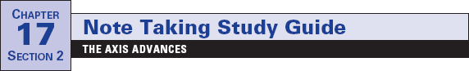

Focus Question: Which regions were attacked and occupied by the Axis
powers, and what was life like under their occupation?
A. As you read “The Axis Attacks,” “Germany Invades the Soviet Union,” and
“Japan Attacks the United States,” use the chart below to record the sequence of
events. Some items have been entered for you.
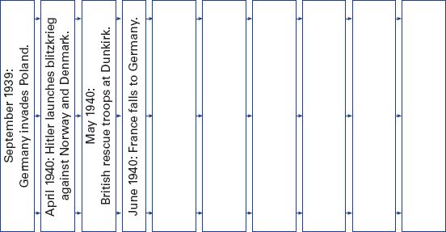

B. As you read “Life Under Nazi and Japanese Occupation,” use the concept web to
list supporting details about the occupations. Some items have been entered for you.

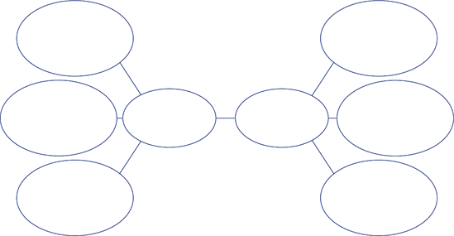
Treated
conquered
people brutally
Slavs
considered
inferior.

Nazi
occupation
Japanese
occupation

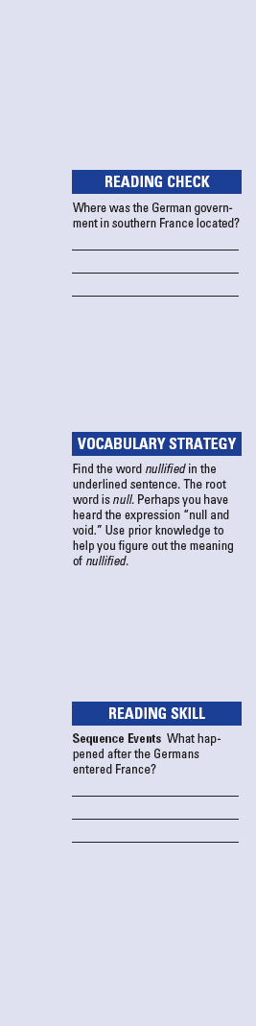
Name Class Date
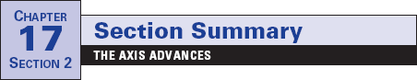

In September 1939, Nazi forces launched a blitzkrieg against
Poland. First, the Luftwaffe bombed Poland from the air. Then,
tanks and troops pushed in. At the same time, Stalin’s forces
invaded from the east. Poland disappeared.
In early 1940, Hitler’s troops conquered Norway, Denmark,
the Netherlands, and Belgium. By May, German forces pushed
into France. British troops that had been sent to help the
French were trapped. Using every boat available, the British
rescued their troops from Dunkirk. The French gave up, and
Germany took over northern France. In southern France, they
set up a puppet government in Vichy.
Hitler bombed Britain continuously between September
1940 and June 1941 to prepare for an invasion. Despite this
blitz, the British did not give in. In North Africa, General
Erwin Rommel pushed the British back toward Cairo, Egypt.
By 1941, Axis powers controlled most of Europe. The Japanese
were invading lands in Asia and the Pacific.
In June 1941, Hitler nullified the Nazi-Soviet Pact by invad-
ing the Soviet Union. The Soviets were not prepared, and the
Germans advanced toward Moscow and Leningrad. During a
lengthy siege of Leningrad, more than a million people died.
The severe Russian winter finally slowed the German advance.
As they marched across Europe, the Nazis sent millions to
concentration camps to work as slave laborers. Even worse,
Hitler established death camps to kill those he judged racially
inferior. Among many others, some six million Jews were
killed in this Holocaust.
The United States declared neutrality at the start of the war.
Yet, many Americans were sympathetic to those fighting the
Axis powers. Congress passed the Lend-Lease Act of 1941 to
allow the United States to sell or lend war materials to nations
fighting the Axis powers. Then, on December 7, 1941, the
Japanese attacked the U.S. fleet at Pearl Harbor. Congress
declared war on Japan.
Review Questions
1. Why did Hitler bomb Britain?

2. Why was Hitler able to invade the Soviet Union?

Name Class Date
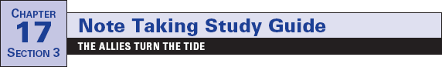

Focus Question: How did the Allies begin to push back the Axis powers?
As you read this section in your textbook, complete the chart below to record the
sequence of events that turned the tide of the war in favor of the Allies. Some events
have been completed for you.

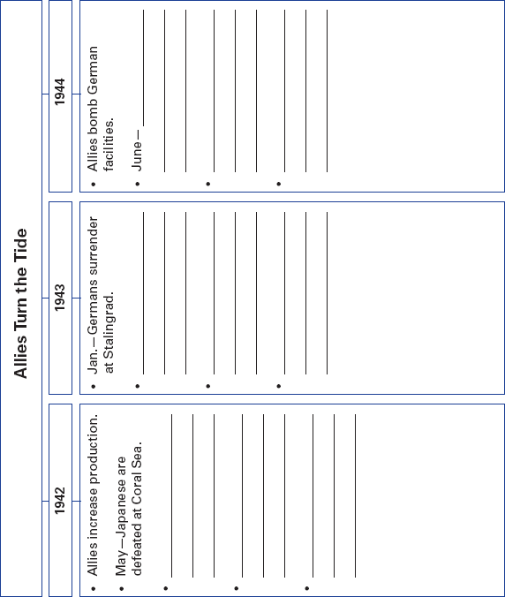

183

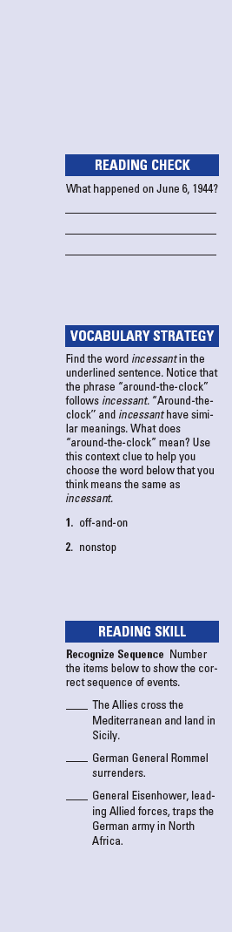
Name Class Date
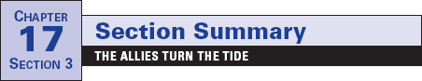

To defeat the Axis powers in World War II, the Allies devoted
all their resources to the war effort. Governments took a
greater role in the economy. For example, auto factories were
ordered to make tanks. Consumer goods were rationed. Wages
and prices were controlled. The increase in production helped
to end the unemployment of the Great Depression. However,
governments also limited people’s rights, censored the press,
and used propaganda to win public support. At the same time,
as men joined the military, women replaced them in factories.
These women were symbolized by “Rosie the Riveter.”
The years 1942 and 1943 marked the turning point of the
war. In the Pacific, the Japanese lost the battles of the Coral Sea
and Midway. In both battles, air attacks were launched from
huge aircraft carriers. In North Africa, British and American
forces, led by General Dwight Eisenhower, trapped the
German army. German General Rommel surrendered in May
1943. The Allies then crossed the Mediterranean to Sicily. Allied
victories in Italy led to the overthrow of Mussolini, although the
fighting continued for another 18 months. On the Eastern front,
a key turning point was the Battle of Stalingrad. After brutal
fighting, the Soviet army surrounded the German troops.
Without food or ammunition, the Germans surrendered.
On June 6, 1944, the Allies began the D-Day invasion of
France. Allied troops faced many obstacles, but the Germans
finally retreated. As the Allies advanced, Germany was hit with
incessant, around-the-clock bombing. A German counterattack,
the Battle of the Bulge, caused terrible losses on both sides. The
defeat of Germany seemed inevitable, however. The “Big Three”
—Roosevelt, Churchill, and Stalin—met to plan for the end of
the war. At this Yalta Conference, the Soviets agreed to enter
the war against Japan. They also agreed to divide Germany into
four zones of occupation after the war. However, growing mis-
trust at Yalta hinted at a future split among the Allies.
Review Questions
1. What did “Rosie the Riveter” symbolize?

2. What agreement about Germany was made at the Yalta
Conference?

Name Class Date
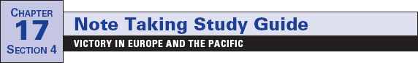

Focus Question: How did the Allies finally defeat the Axis powers?
As you read this section in your textbook, use the timeline below to recognize the
sequence of events that led to the defeat of the Axis powers. Some events have been
completed for you.

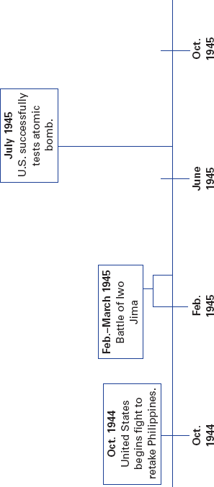

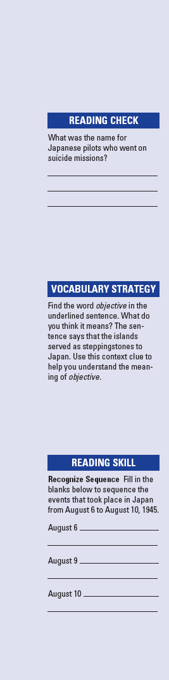
Name Class Date
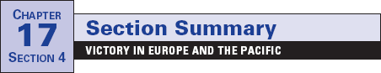

World War II in Europe officially ended on May 8, 1945. This is
known as V-E Day. The Allies were able to defeat the Germans
for many reasons. The Germans had to fight on several fronts at
the same time. Hitler also made some poor decisions. He under-
estimated the Soviet Union’s ability to fight. The enormous pro-
duction capacity of the United States was another factor. By
1944, the United States was producing twice as much as all of
the Axis powers combined. Bombing hurt German production
and made oil scarce. This kept the Luftwaffe from flying
Once Germany was defeated, the Allies still had to defeat
the Japanese in the Pacific. By May 1942, the Japanese con-
trolled much of Southeast Asia, many Pacific islands, and the
Philippines. They had killed thousands during the Bataan
Death March. The United States now took the offensive.
General Douglas MacArthur began an “island-hopping” cam-
paign. The campaign took back islands from the Japanese.
These islands served as steppingstones to the next objective—
Japan. By 1944, the U.S. Navy was blockading Japan. Bombers
pounded Japanese cities and industries.
In early 1945, bloody battles on Iwo Jima and Okinawa
showed that the Japanese would fight to the death rather than
give up. Some young Japanese became kamikaze pilots, crash-
ing their planes into U.S. warships. Scientists now offered
another way to end the war. Their research, called the
Manhattan Project, had produced an atomic bomb for the
United States. The new U.S. president, Harry Truman, decided
that dropping the bomb would save American lives. The Allies
first gave the Japanese a warning to surrender or face “utter
and complete destruction.” The Japanese ignored the warning.
On August 6, 1945, a U.S. plane dropped an atomic bomb on
the city of Hiroshima. This bomb killed more than 70,000 peo-
ple. The Japanese still did not give up. Another bomb was
dropped on Nagasaki on August 9. The next day, Japan finally
surrendered, ending World War II.
Review Questions
1. What is V-E Day?

2. What was the Manhattan Project?

Name Class Date
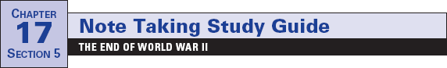

Focus Question: What issues arose in the aftermath of World War II and
how did new tensions develop?
As you read the section in your textbook, recognize the sequence of events following
World War II by completing the outline below. Some items have been filled in.
I. The War’s Aftermath
A. Devastation
1. As many as 50 million are dead.
2. Horrors of Holocaust are learned.
B. War Crimes Trials
1. Axis leaders are tried for crimes against humanity.
2. Many of those accused are never captured or brought to trial.
3. Political and military leaders are held accountable for wartime
actions.
C. Occupying Allies
1. Totalitarian ideologies are discredited.
2.
II. Establishing the United Nations
A. General Assembly
1.
B. Security Council
1.
2.
C. Other UN activities
1.
2.
III. The Alliance Breaks Apart
A. Differences Grow Between the Allies.
1.
2.
B. The Cold War Begins.
1.
2.

(Outline continues on the next page.)

187
Name Class Date
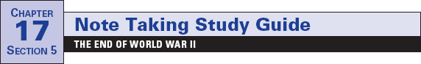

(Continued from page 187)
3.
IV. New Conflicts Develop
A. The Truman Doctrine
1. Results from Soviet incursions into southeastern Europe
2.
3.
B. The Marshall Plan
1. United States gives food and economic assistance to European
nations.
2.
3.
C. Germany Stays Divided.
1.
2.
3.
4.
D. Berlin Airlift
1.
2.
3.
E.
1.
2.
F.
1.
2.

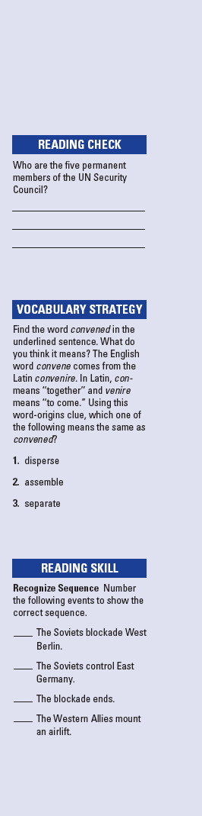
Name Class Date
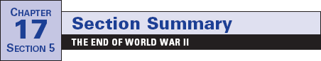

The costs of World War II were great. As many as 50 million
people had been killed. At the end of the war, the Allies
learned the full extent of the Holocaust. War crimes trials were
held in Nuremberg, Germany, and in other countries. These
trials showed that leaders could be held accountable for their
wartime actions. After the war, the Western Allies wanted to
ensure peace. As a result, they helped to set up democratic
governments in Japan and Germany.
In 1945, delegates from 50 nations convened to form the
United Nations. Each member nation has one vote in the
General Assembly. A smaller Security Council has greater
power. It has five permanent members: the United States, the
Soviet Union (today Russia), Britain, France, and China. Each
has the right to vote down any council decision.
However, distrust and different philosophies soon led to a
Cold War. This refers to the state of tension between the
United States and the Soviet Union between 1946 and 1990.
Soviet leader Stalin wanted to spread communism into Eastern
Europe. He also wanted to have pro-Soviet countries between
the Soviet Union and Germany. By 1948, communist govern-
ments were in place throughout Eastern Europe.
Stalin soon began to threaten Greece and Turkey. The
United States responded with the Truman Doctrine. This poli-
cy meant that the United States would resist the spread of com-
munism throughout the world. To strengthen democracies, the
United States offered food and economic aid to Europe. This
assistance was called the Marshall Plan. However, the Soviets
now controlled East Germany, which surrounded the city of
Berlin. To force the Western Allies out of Berlin, the Soviets
blockaded West Berlin. An airlift by the Western Allies forced
the Soviets to end the blockade. Tensions continued to grow. In
1949, the United States and nine other nations formed a new
alliance called the North Atlantic Treaty Organization
(NATO). The Soviets then formed the Warsaw Pact.
Review Questions
1. What was the basic idea of the Truman Doctrine?

2. What two new alliances were formed after World War II?

