Name Class Date

Focus Question: What were the military and political consequences of
the Cold War in the Soviet Union, Europe, and the United States?
As you read this section in your textbook, fill in the chart to summarize the
consequences of the Cold War in the Soviet Union, Europe, and the United States.
Some items in the chart have been entered for you.

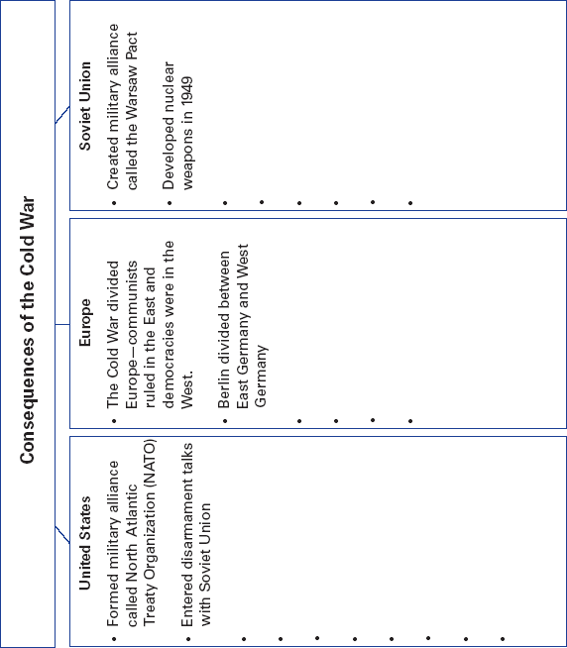

190
Name Class Date

After World War II, the United States and the Soviet Union
emerged as superpowers. They formed military alliances with
nations they protected or occupied. The United States helped
form the North Atlantic Treaty Organization (NATO). This
comprised its Western European allies. The Soviet Union
formed the Warsaw Pact with Eastern European countries.
The superpowers also took part in a nuclear weapons race.
Throughout the Cold War, the leaders met in disarmament
talks. One agreement limited the use of anti-ballistic missiles
(ABMs). These weapons were designed to shoot down incom-
ing missiles. ABMs were a threat because they could give one
side more protection. Some believed that more protection
might encourage a nation to attack. In the 1980s, U.S. President
Ronald Reagan supported a missile defense program known
as “Star Wars.” However, international agreements to limit the
number of nuclear weapons eased Cold War tensions. This
period, called the era of détente, ended with the Soviet inva-
sion of Afghanistan in 1979.
The Cold War was a global conflict. During the 1950s, Fidel
Castro led a revolution in Cuba and became its leader. To
bring down Castro’s communist regime, U.S. President John F.
Kennedy supported an invasion of Cuba, but it failed. One
year later, the Soviets sent nuclear missiles to Cuba. Many
feared a nuclear war. After U.S. protests and a naval blockade,
Soviet leader Nikita Khrushchev agreed to remove the missiles.
The Soviets wanted to spread communist ideology around
the globe. Although Khrushchev halted some of Stalin’s cruel
policies, repression returned under Leonid Brezhnev. U.S.
leaders followed a policy of containment to keep communism
from spreading to other nations. In the United States a “red
scare” developed. During this time, Senator Joseph McCarthy
led a hunt for communists he thought were in the U.S. govern-
ment and military.
Review Questions
1. What military alliances did the United States and the Soviet
Union form after World War II?

2. What were ABMs and why were they considered a threat?

191

Name Class Date

Focus Question: How did the United States, Western Europe, and Japan
achieve economic prosperity and strengthen democracy during the Cold
War years?
As you read this section in your textbook, use the chart below to categorize economic
and political changes in the industrialized democracies. Some items have been entered
for you.
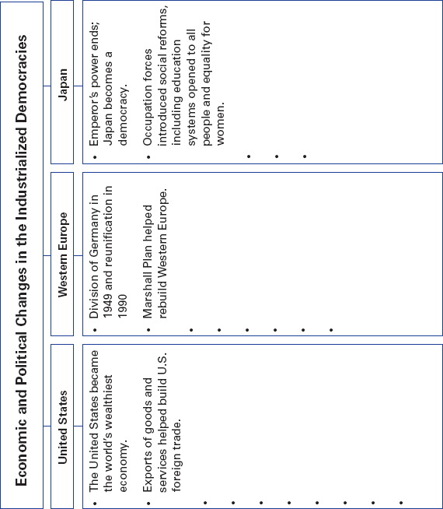

192
Name Class Date

Postwar economic strength changed life in the United States.
During the 1950s and 1960s, recessions were brief and mild. As
Americans prospered, they had more money to spend on goods.
Many people left the cities for homes in the suburbs. This move-
ment is called suburbanization. By the early 1970s, however,
higher oil and gas prices left Americans with less money to buy
other goods. This caused a serious recession in 1974.
Despite the prosperity, ethnic minorities faced segregation
in housing and education. Also, minorities suffered
discrimination in jobs and voting. Dr. Martin Luther King, Jr.,
became an important civil rights leader in the 1960s. He helped
end segregation for African Americans. Other minority groups
were inspired by successes like these. For example, the
women’s rights movement helped end much gender-based
discrimination. Also, Congress created programs to help the
poor. However, in the 1980s, the government reduced many of
these programs.
Western Europeans rebuilt after World War II. The Ameri-
can Marshall Plan helped European countries restore their
economies. Under Chancellor Konrad Adenauer, Germany built
modern cities and factories. European governments also devel-
oped programs for the poor and middle class, such as national
healthcare and old-age pensions. These welfare states required
high taxes to pay for their programs.
Not long after the war, European nations began working
together to improve trade and increase their economic power.
This cooperation led to the start of the European Community.
It made it possible for members to trade freely with each other.
Much of Japan was destroyed during the World War II.
Afterward, occupation forces introduced social changes, such
as land reform and equal rights for women. Like Germany,
Japan also built new factories. Its gross domestic product
(GDP) soared. Japan succeeded by making goods for export.
Review Questions
1. List two results of the strong, postwar U. S. economy.

2. What was the purpose of the European Community?

193

Name Class Date

Focus Question: What did the Communist victory mean for China and
the rest of East Asia?
As you read this section in your textbook, complete the flowchart below to help you
summarize the effects of the Communist Revolution on China and the impact of the
Cold War on China and Korea. Some items have been filled in for you.

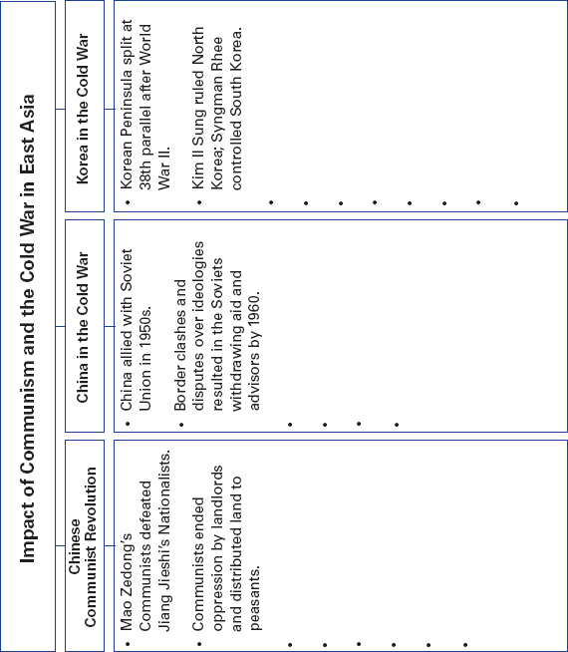

194
Name Class Date

After World War II, Mao Zedong led communist forces to vic-
tory over the Nationalists, who fled to Taiwan. Mao then
began to reshape China’s economy. He gave land to the peas-
ants. Then he called for collectivization, or the pooling of land
and labor. As part of the Great Leap Forward, people moved
from small villages and individual farms into communes of
thousands of people on thousand of acres. Communes were
supposed to grow more food and produce more goods.
Instead, the system produced useless or low-quality goods and
less food. To remove “bourgeois” tendencies, Mao also began
the Cultural Revolution. Skilled workers and managers were
forced to work on farms or in labor camps. This resulted in a
slowed economy and a threat of civil war.
At first, the United States supported the Nationalist gov-
ernment that had formed on Taiwan. The West was concerned
that the Soviet Union and China would become allies. As the
Cold War continued, however, the Soviets withdrew their aid
and advisors from China. U.S. leaders thought that by “play-
ing the China card,” or improving relations with the Chinese,
they would isolate the Soviets even more. In 1979, the United
States established diplomatic relations with China.
After World War II, American and Soviet forces had agreed
to divide Korea at the 38th parallel. Communist Kim Il Sung
ruled the North and U.S. ally Syngman Rhee ruled the South.
In 1950, North Korean troops attacked South Korea. The
United Nations forces stopped them along a line known as the
Pusan Perimeter, then began advancing north. Mao sent
Chinese troops to help the North Koreans. The UN forces were
pushed back south of the 38th parallel. In 1953, both sides
agreed to end the fighting, but troops remained on either side
of the demilitarized zone (DMZ). Over time, South Korea
enjoyed an economic boom, while communist North Korea’s
economy declined.
Review Questions
1. What was the purpose of the Great Leap Forward?

2. What was the 38th parallel?

195
Name Class Date

Focus Question: What were the causes and effects of war in Southeast
Asia, and what was the American role in this region?
As you read this section in your textbook, complete the flowchart below to summarize
the events in Southeast Asia after World War II. Some items have been filled in for you.

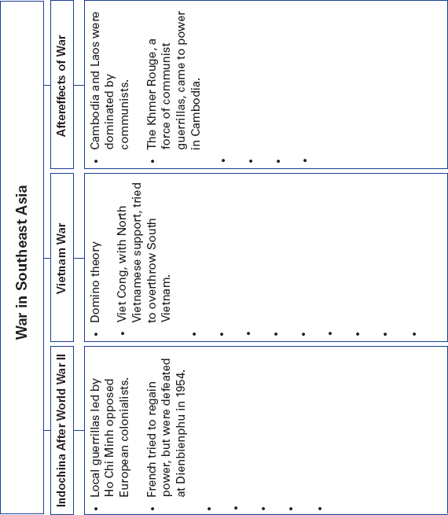

196
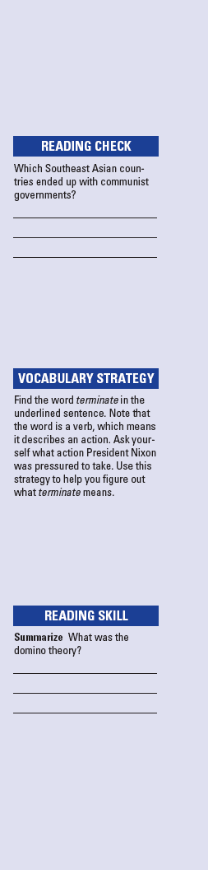
Name Class Date

In the 1800s, the French ruled the area in Southeast Asia called
French Indochina. During World War II, Japan tried to take
over, but faced resistance from guerrillas. After the war, the
French tried to regain control, but the Vietnamese, led by Ho
Chi Minh, fought them. The French were defeated at the battle
of Dienbienphu. After that, Ho controlled the northern part of
Vietnam while the United States supported the noncommunist
government in the south. Ho supported communist guerrillas
in the south, called Viet Cong.
U.S. leaders saw Vietnam as an extension of the Cold War.
They developed the domino theory. This was the view that if
communists won in South Vietnam, communism would spread
throughout Southeast Asia. In 1964, the North Vietnamese
attacked a U.S. naval ship. Congress granted the president the
power to take military action to stop further communist aggres-
sion in the region. Eventually, more than 500,000 American
troops fought in what became known as the Vietnam War.
Despite U.S. support for South Vietnam, the Viet Cong con-
tinued to attack. During the Tet Offensive, Viet Cong and
their North Vietnamese allies attacked cities all over the south.
Even though the communists were not able to hold any cities,
the attack was a turning point in U.S. public opinion. Upset by
civilian and military deaths, many Americans began to oppose
the war. President Nixon came under increasing pressure to
terminate the conflict. He signed the Paris Peace Accord in
1973, and U.S. troops soon withdrew. Two years later, North
Vietnam conquered South Vietnam. Thousands of Vietnamese
tried to leave the country.
Communism did spread to neighboring countries. In
Cambodia, communist guerrillas called the Khmer Rouge
came to power. Their ruler, Pol Pot, oversaw forced work
camps and the genocide of more than a million Cambodians.
Laos also ended up with a communist government. However,
communism did not spread any farther in Southeast Asia.
Review Questions
1. What did Congress do in 1964?

2. Who were the Khmer Rouge?

197

Name Class Date
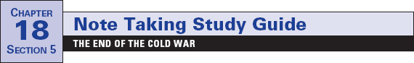

Focus Question: What were the causes and the effects of the end of the
Cold War?
As you read this section in your textbook, complete this flowchart to help you categorize
events connected to the end of the Cold War. Some items have been completed for you.

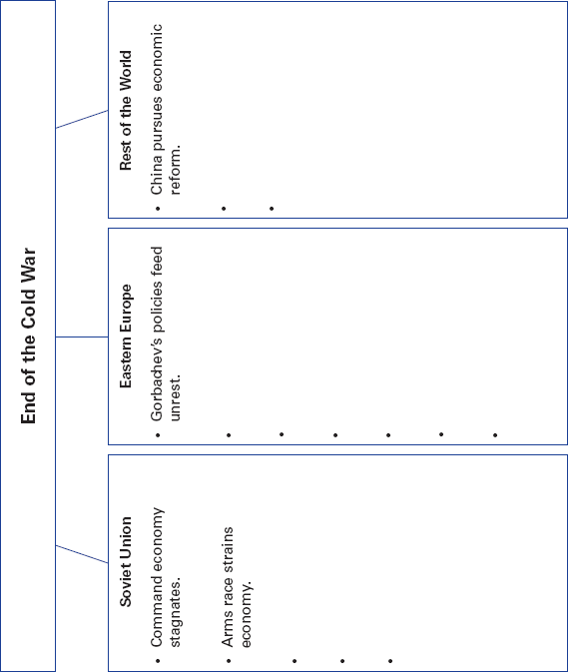

198
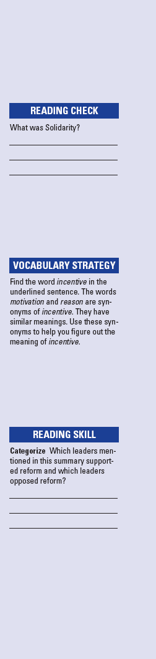
Name Class Date
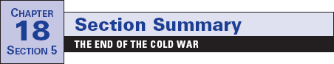

The Soviet Union emerged from World War II as a superpower
with control over many Eastern European countries. When
challenged, the Soviet Union used its military to subdue
unrest. However, the Soviet command economy could not pro-
duce enough food to feed its people. Consumer products were
poorly made and workers were poorly paid. Lifetime job secu-
rity, however, meant that they did not have to worry about los-
ing their jobs. Therefore, workers had little incentive to
produce higher-quality goods. Further economic strain came
when Soviet forces invaded Afghanistan in 1979. They had few
successes battling the mujahedin, or Muslim religious warriors.
Soviet leader Mikhail Gorbachev urged reforms. He called
for glasnost, or openness. He ended censorship and encour-
aged people to discuss the country’s problems. Gorbachev also
called for perestroika, or a restructuring of the government
and economy. His policies, however, fed unrest across the
Soviet empire. Eastern Europeans began to demand an end to
Soviet rule. By the end of the 1980s, a powerful democracy
movement was sweeping the region. In Poland, Lech Walesa
led Solidarity, an independent labor union demanding eco-
nomic and political changes.
Meanwhile, East German leaders resisted reform, and thou-
sands of East Germans fled to the West. In Czechoslovakia,
Václav Havel, a writer who fought for independence, was
elected president. One by one, communist governments fell.
Most changes happened peacefully, but when Romanian dicta-
tor Nicolae Ceausescu refused to step down, he was executed.
The Baltic States regained independence. By the end of 1991,
the remaining Soviet republics had all formed independent
nations. The Soviet Union ceased to exist.
In 1992, Czechoslovakia was divided into Slovakia and the
Czech Republic. Additionally, some communist governments
in Asia, such as China, instituted economic reforms.
Review Questions
1. What were some problems with the Soviet economy?

2. What kinds of reforms did Gorbachev make?

199

