Name Class Date

Throughout the Cold War, communist and capitalist systems competed for influence
around the globe. In the passages below, two economists explain some benefits or
positive aspects of each system. The first excerpt is by an eminent Soviet economist.
It appeared in a pamphlet published for an American audience. The second excerpt
is from an influential book written by a U.S. economics professor. ♦ As you read, think
about how economic decisions are made in each system. Then, on a separate sheet of paper,
answer the questions that follow.

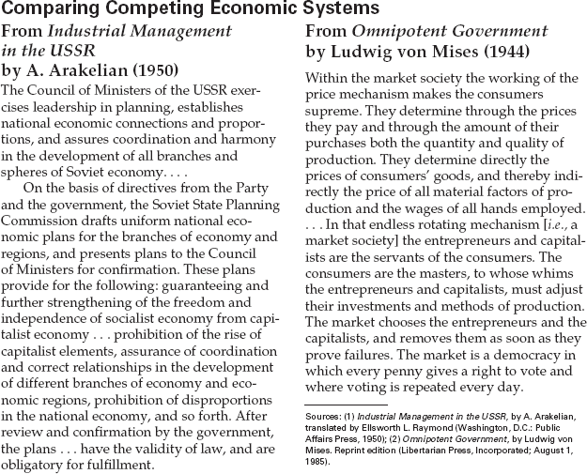

1. According to Arakelian, who decides what
will be produced in the Soviet Union?
2. According to von Mises, who decides what
will be produced in the United States?
3. Make Comparisons What would Arakelian
argue is a weakness of the capitalist econ-
omy? What would von Mises argue is a
weakness in the socialist economy? What do
you think is one strength of each system?

10
Name Class Date

After the fall of the Berlin Wall in late 1989, East and West Germans had different ideas about the benefits
and drawbacks of a reunified Germany. A group of East German reformers expressed their opinions in an
appeal in 1989. West German Chancellor Helmut Kohl presented a case in favor of reunification in 1990.
♦ As you read, think about why different opinions regarding reunification emerged. Then, on a separate sheet of
paper, answer the questions that follow.

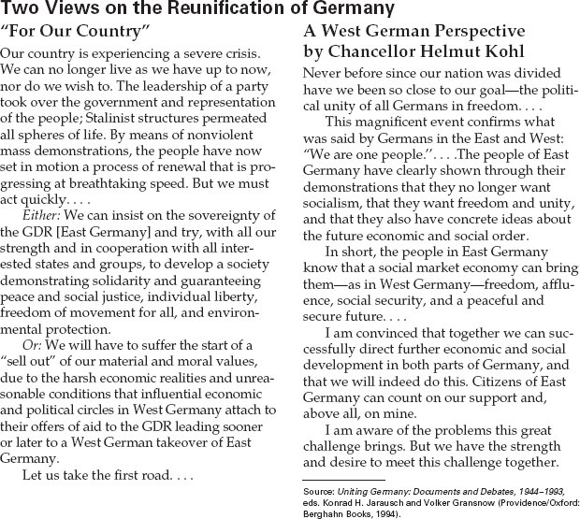

1. What do the authors of “For Our Country”
want to happen to East Germany?
2. Draw Inferences What might be some of the
challenges that Chancellor Kohl says reunifi-
cation will bring?
3. Make Comparisons Under which system—
the one described by Kohl or by the authors
of “For Our Country”—would you prefer to
live? Why?

13

