Name Class Date

The brilliant growth of the arts during the Renaissance depended greatly on the sup-
port and the fortunes of wealthy patrons, to whom it brought prestige. One of the
most famous Renaissance patrons and collectors was Isabella d’Este, who was also
influential in politics. ♦ As you read, think of how the arts are supported today. Then, on a
separate sheet of paper, answer the questions that follow.
Isabella d’Este (1474–1539)

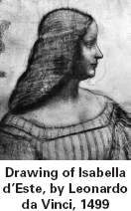
If you look through a book of Renaissance art,
you are likely to see a portrait of Isabella
d’Este. She was one of the super-
stars—the “rich and famous”—of
her time. The artists Leonardo da
Vinci and Titian both painted her
portrait. One diplomat called her
“the First Lady of the world.”
Others admired both her brilliant
mind and her personal grace and
charm.
Isabella’s own family, the
d’Estes, ruled the Italian state of
Ferrara. Their palace was filled with
fine paintings and tapestries, and
they enjoyed putting on elaborate
plays, with musicians and clowns, in the
palace courtyard. Isabella learned to speak and
write Latin, which was not only the language
of the Church and diplomacy, but also neces-
sary to enjoy Latin classics such as the Aeneid.
Like most daughters in noble families, both
Isabella and her sister, Beatrice, were formally
engaged as children: Isabella to Gianfrancesco
Gonzaga, whose family ruled Mantua, and
Beatrice to the son of the powerful Sforzas of
Milan. Isabella and Gianfrancesco were mar-
ried in a lavish wedding when she was 16.
Gianfrancesco was a skillful soldier and,
besides leading his own state of Mantua, was
captain of the Venetian army. The Italian city-
states fought numerous small wars and made
foreign alliances to ensure their independence.
Gianfrancesco was often away at
war, leaving Isabella to govern
Mantua.
In spite of the wars, court life in
Renaissance Italy was luxurious.
Courtiers had leisure time for
games—chess, cards, charades—
and dancing. Isabella spent huge
amounts of money on festive enter-
tainments at court and on mainte-
nance of the palace, with its many
servants and horses. She bought
extravagant clothes, furs, and jew-
elry, setting styles throughout
Europe.
Neglected by her husband, Isabella deter-
mined to outshine him in politics and as an
art patron. She had grown up with great art
and became a collector. She commissioned
works by painters, sculptors, and jewelers.
The famous printer Aldus Manutius printed
special editions of books for her. She bought
ancient Greek and Roman art.
Isabella also played skillfully in the com-
plex politics of the time. She kept Mantua
neutral and independent. After Gianfrancesco
died in 1519, she ruled the state, later handing
it over to her son.

1. What was Isabella d’Este’s family back-
ground and her position in Italian society?
2. What part did Isabella d’Este play in the
realm of Renaissance art?
3. Determine Relevance Why was it important
to be able to read, write, and speak Latin
during the Renaissance?

9
Name Class Date

William Shakespeare (1564–1616) is widely considered to be one of the greatest English writers of
all time. His plays and poems have fascinated readers for almost four centuries. Among his works
are his tragedies, such as Hamlet, King Lear, Othello, and Macbeth. Macbeth tells the story of the title
character, a medieval Scottish lord driven by greed and ambition. In his desire to gain more
power, he is persuaded by his wife to murder the king of Scotland and seize the throne.
Macbeth’s enemies have now surrounded his castle and it appears that his end is near. He has just
heard that his wife has gone insane from guilt over this crime and committed suicide. Macbeth’s
reaction to this news is expressed below in one of the most famous soliloquies* in all of
Shakespeare’s plays. ♦ As you read, think about how Shakespeare used carefully chosen words to express
Macbeth’s thoughts and feelings. Then, on a separate sheet of paper, answer the questions that follow.

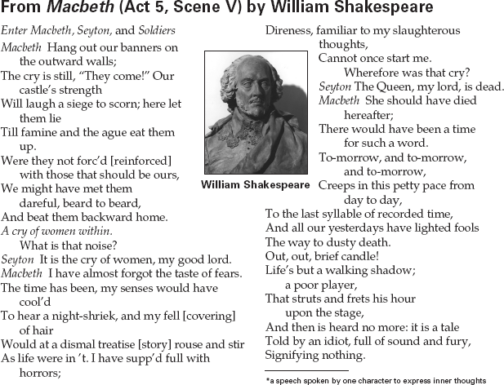

1. To what does Macbeth compare life?
2. Summarize Using everyday language, para-
phrase Macbeth’s soliloquy about death at
the end of the excerpt
3. Synthesize Information Shakespeare chose
his words carefully to convey Macbeth’s
thoughts and feelings to people watching the
play. What words does Shakespeare use to
reveal Macbeth’s fears?

11
Name Class Date

Historians date the beginning of the Protestant Reformation to the moment when Martin Luther
wrote a public letter to Archbishop Albrecht of Mainz. The letter, which became known as
Luther’s 95 Theses, included a list of arguments against the Church’s practice of selling indul-
gences. While the Church had made indulgences available for centuries, the practice had
increased as papal finances worsened. Luther posted the 95 Theses on the door of a church in
Wittenberg, Germany, in 1517. ♦ As you read, think about how people of Luther’s time may have reacted
to his ideas. Then, on a separate sheet of paper, answer the questions that follow.
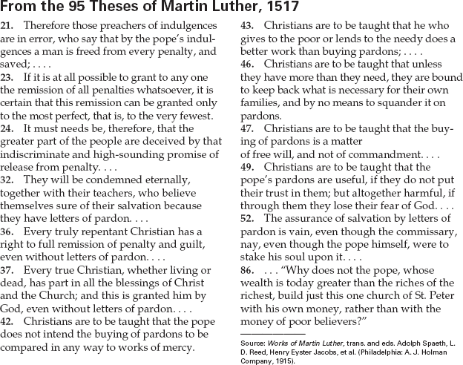

1. What is Luther’s attitude toward taking care
of the poor?
2. Recognize Sufficient Evidence What evi-
dence can you find that Germans of the time
were angry because Church leaders forced
them to buy indulgences?
3. Activity Write a first-person journal entry
about Luther’s theses, as though you were a
German Christian in 1517. Include your view
of his arguments and your impressions about
the effects Luther’s actions will have on the
Church.

13
Name Class Date

Modern science got its start in the Scientific Revolution of the 1500s and 1600s. One idea that
caused great controversy was Copernicus’s model of a sun-centered universe. Here two scien-
tists, Galileo Galilei and Johannes Kepler, correspond about the dangers of discussing this the-
ory in public. ♦ As you read, think about the importance of public opinion. Then, on a separate sheet of
paper, answer the questions that follow.
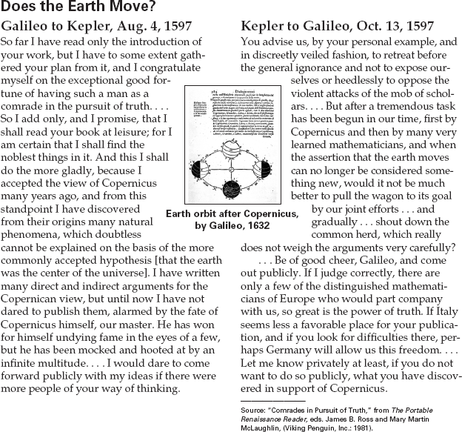

1. Why is Galileo reluctant to publish his ideas
about Copernicus’s theory?
2. What does Kepler suggest as an alternative
to publishing in Italy?
3. Make Comparisons Do you think that scien-
tists today are as worried about the reactions
from the public as Galileo and Kepler were?
Support your opinion with examples.

10

