Name Class Date

There are only a few surviving accounts of the Spanish conquest of Mexico as told by
Aztec authors. This excerpt is from a history written in Nahuatl in 1528, by a group
known as the “anonymous authors of Tlatelolco” (an Aztec city). It describes the
start of the war between the Spanish and the Aztecs. The Spanish were led by
Hernán Cortés, who is referred to as “the Captain” in this excerpt, and his second in
command, Pedro de Alvarado, who is referred to as “The Sun.” ♦ As you read, think
about how the Spanish soldiers viewed this incident. Then, on a separate sheet of paper,
answer the questions that follow.
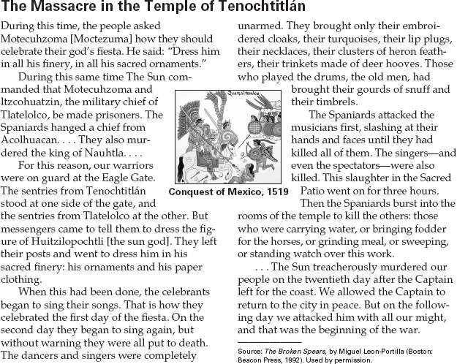

1. What actions by the Spanish had made the
Aztecs wary?
2. How were the Aztecs celebrating the festival
of the sun god?
3. Recognize Cause and Effect How did the
Aztecs respond to the massacre?
4. Activity The Aztecs believed in many gods
and goddesses. Huitzilopochtli was their
main god. Research Aztec religion and create
a chart that names ten other important gods
of the Aztecs. Include a brief description and
background information about each of the
gods.

51
Name Class Date

When they first arrived, Hernán Cortés and his men spent several days with the Aztec emperor
Moctezuma (spelled Montezuma here) in the capital city of Tenochtitlán. Moctezuma welcomed
Cortés’s group and even took them to the top of the great temple to view the splendor of the
city. Later, relations grew strained after Cortés criticized the Aztecs’ religion. In this excerpt,
Bernal Díaz del Castillo, one of Cortés’s soldiers, describes his group’s experiences before and
after relations deteriorated. ♦ As you read, think about the emotions these men felt once knew they had
angered Montezuma. Then, on a separate sheet of paper, answer the questions that follow.

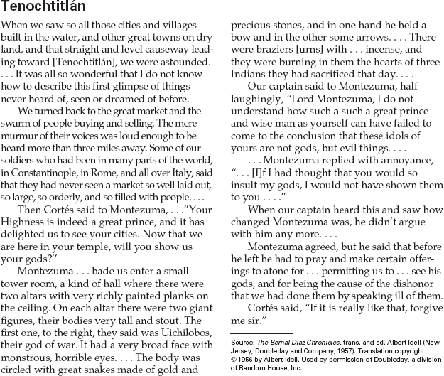

1. What causes relations to deteriorate
between Moctezuma and the Spanish?
2. Identify Bias What assumptions do you think
Cortés and his men have about religion and
the beliefs of the Aztecs?
3. Activity Write a short story on what life there was like before and after the city was conquered by
the Spanish.
Name Class Date

Conquest by the Spanish brought hardships and slavery for the original inhabitants
of the Americas. Most Spanish colonial officials, such as Juan de Solorzano y Pereyra,
backed official policy. However, one missionary, Bartolomé de Las Casas, became
the Native Americans’ strongest defender, both in Spain and in the colonies. ♦ As
you read, consider the different attitudes these excerpts reveal. Then, on a separate sheet of
paper, answer the questions that follow.

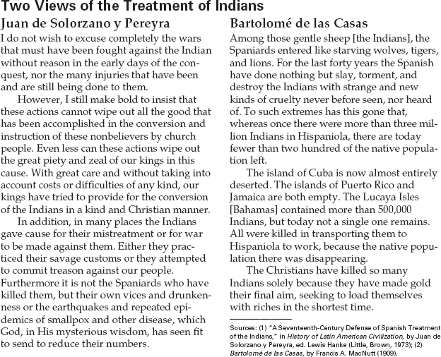

1. For Juan de Solorzano, what “good” out-
weighs the harsh treatment of the Indians?
What other justifications does he find for
their treatment?
2. According to Las Casas, what has happened
to the native populations of the Caribbean
islands?
3. Recognize Bias How does Las Casas reveal
his bias against the Spanish treatment of the
native peoples? What words or phrases does
he use to describe them?
4. Recognize Ideologies What beliefs do you
think may have motivated Las Casas to take
the stand that he does?

50
Name Class Date

Recognize Sequence
When you talk about something that happened to you, you probably tell the story in
order. This is known as putting information in sequence. As you read, it helps to rec-
ognize sequence because you will understand how events unfold and lead to other
events.
In a history textbook, events are often presented in chronological order. It helps
to create a timeline based on the information you have read to understand and
remember the sequence of events. Read the following paragraph about the first
colonies established by the English.
In 1497, Venetian navigator John Cabot found rich fishing grounds off
Newfoundland, which he claimed for England. In the 1600s, England con-
centrated on establishing colonies along the Atlantic seaboard. The English
built their first permanent colony in Jamestown, Virginia, in 1607. In 1620,
another group of English settlers, known as Pilgrims, landed at Plymouth,
Massachusetts. During the 1600s and 1700s, the English established
additional colonies.
The sequence of events in this paragraph is:

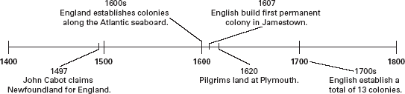

Directions: Read Section 3 of The Beginnings of Our Global Age: Europe and the Americas
under the heading “Struggling for Power.” On a separate sheet of paper, list, in order, the
dates and names of important events during the British and French struggle for power and
create a timeline. Then, answer the following questions.
Hint: Watch for dates in your textbook to help you create the sequence of
events.

1. What is important about the year 1754?

2. What took place in 1756?

3. What key event happened in 1763? What happened to Britain following this event?

48

