Name Class Date

The Enlightenment began in France with the brilliant circle of thinkers and reformers
known as philosophes. Probably the most renowned throughout all Europe was the
writer Voltaire, whose works people still enjoy today. ♦ As you read, think about the
courage it took at that time to criticize powerful institutions such as the Church and the gov-
ernment. Then, on a separate sheet of paper, answer the questions that follow.
Voltaire (1694 –1778)

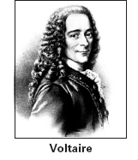
It is hard to imagine one single person today
influencing people’s thinking as deeply as did
the French writer known as Voltaire. In his
own time he was considered a great poet and
playwright, while today people enjoy the wit
and biting humor of his tales and essays. He
ridiculed all kinds of rules, ideas, and behav-
ior that he thought were intolerant, unfair,
cruel, or simply stupid. People still
enjoy the witty satire of his story
Candide, in which the always opti-
mistic hero, despite the horrors and
injustices he sees, still goes on say-
ing that, “All is for the best in this
best of all possible worlds.” Candide
is so entertaining that American
composer Leonard Bernstein made
it the basis for a Broadway musical
first presented in 1956.
Born in Paris, Voltaire’s real
name was François-Marie Arouet. He
attended a Jesuit college and grew up among
others who were “freethinkers.” His first run-
in with authority came when he was 23 and
imprisoned in the Bastille for some verses he
had written. Later he spent several years in
England, where people had more liberty to
write and say what they thought about con-
troversial subjects like religion. He greatly
admired Britain’s constitutional monarchy,
although he thought an enlightened authori-
tarian ruler was better for France.
Voltaire criticized many things about
French society and government, including
the unjust legal system, press censorship, and
the power and intolerance of the Catholic
Church. These ideas made him unwelcome in
Paris for many years. He spent
some time at the court of Frederick
the Great of Prussia, an “enlight-
ened” monarch who admired
Voltaire’s ideas. He spent most of
the rest of his life at his chateau in
Ferney, on the French border near
Lake Geneva in Switzerland. Visi-
tors, many uninvited, often traveled
there just to meet the great man.
Voltaire was also a historian, set-
ting a new style by including cul-
tural and social ideas as well as political
events in his histories. As a philosophe, he
expressed his ideas in serious essays and
philosophical poems and in tales and books
such as Zadig, Candide, and the Philosophical
Dictionary. His wit and ideas also appear in
the thousands of letters he wrote to writers,
friends, and monarchs all over Europe.

1. What were some of the things about French
society that Voltaire criticized?
2. Which of Voltaire’s works is best known
today and the basis of a musical?
3. Make Comparisons Voltaire admired
Britain’s governmental system. How did
this influence his ideas about the govern-
ment of France?

7
Name Class Date

Frederick II, known as Frederick the Great, ruled Prussia from 1740 to 1786. He was
strongly influenced by Enlightenment thinkers. Frederick was also a leading exam-
ple of an enlightened despot—an absolute ruler who used power to bring about
political and social reforms. ♦ As you read, think about how Frederick viewed his role as a
monarch and how he expressed Enlightenment ideas in his rule. Then, on a separate sheet of
paper, answer the questions that follow.
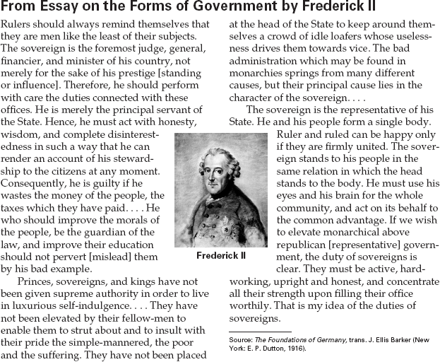

1. What does Frederick think makes a good
ruler?
2. To what does Frederick compare a monarch
and his or her subjects?
3. Predict Consequences Do you think
Frederick’s subjects were satisfied with the
limited independence he offered them?
4. Activity How does Frederick’s description of
what makes a good ruler express Enlighten-
ment ideas? Create a word web showing how
Frederick’s ideas relate to the Enlightenment.

8

1. What does Frederick think makes a good
ruler?
2. To what does Frederick compare a monarch
and his or her subjects?
3. Predict Consequences Do you think
Frederick’s subjects were satisfied with the
limited independence he offered them?
Name Class Date

Robinson Crusoe, written in 1719, tells the story of a fictional shipwreck survivor,
Robinson Crusoe. Crusoe lives on a tropical island for many years, with only a few
supplies from his wrecked ship and what he could make or hunt for himself. In this
excerpt, Crusoe has just landed on the island. ♦ As you read, think about how Crusoe’s
behavior expresses Enlightenment values and ideas. Then, on a separate sheet of paper,
answer the questions that follow.

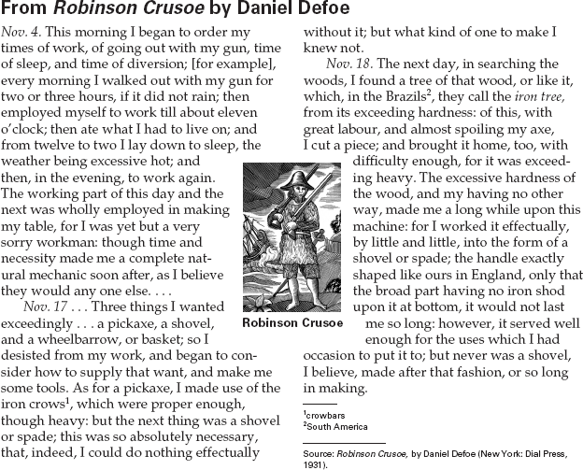

1. What is the first problem Crusoe addresses in
this excerpt?
2. Draw Inferences Crusoe follows a regular sched-
ule and carefully plans each new project. What
do you think Defoe is saying about the use of rea-
son to solve problems? Why?
3. Draw Conclusions Write a paragraph
explaining how you think the story
Robinson Crusoeexpresses Enlighten-
ment values.

9

Name Class Date

The Battle of Cowpens was fought in present-day South Carolina in 1781. In the
excerpts below, two soldiers describe the battle. James Collins was an American foot
soldier serving under Daniel Morgan, and Roderick Mackenzie was a British infantry
officer under the command of Banastre Tarleton. ♦ As you read, think about what might
cause soldiers in battle to view the same events differently. Then, on a separate sheet of paper,
answer the questions that follow.

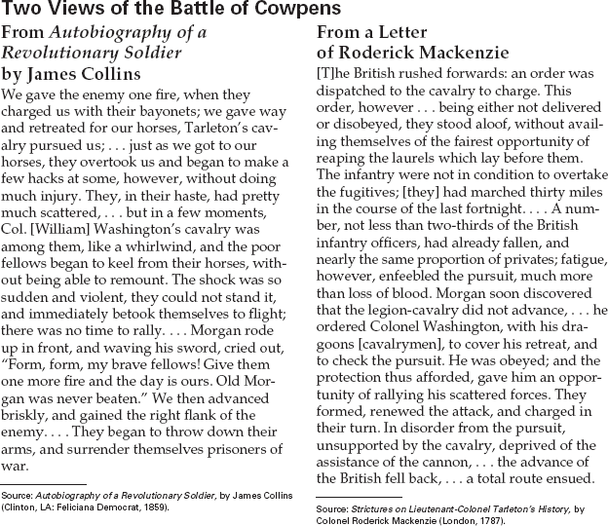

1. Who won the battle: the Americans or the
British?
2. Make Comparisons What reasons do the two
soldiers give for the outcome of the battle?
3. Draw Inferences Why might soldiers on dif-
ferent sides attribute the outcome of a battle
to different causes?

11

