Name Class Date

Focus Question: What effects did Enlightenment philosophers have on
government and society?
As you read this section in your textbook, complete the following table to summarize
each thinker’s works and ideas. Some items have been completed for you.
Thinkers’ Works and Ideas

Hobbes
Leviathan

Two Treatises of Government
Locke

Montesquieu

74
Name Class Date

In the 1500s and 1600s, the Scientific Revolution changed the
way people looked at the world. They began to use reason and
science to learn how things worked. For example, they found
that rules govern natural forces such as gravity. Scientists and
others began to call these rules the natural law. They believed
that natural law could be used to solve society’s problems, too.
In this way the Scientific Revolution sparked another revolu-
tion in thinking known as the Enlightenment.
Two important English thinkers of the Enlightenment were
Thomas Hobbes and John Locke. Hobbes argued that people
were naturally cruel and selfish. They needed to be controlled
by a powerful government, such as an absolute monarchy.
According to Hobbes, people made an agreement, or social
contract. In this contract, people gave up their freedom in
exchange for an organized society. In contrast, Locke thought
that people were basically good. He believed that people had
natural rights, or rights that belonged to all humans. These are
the right to life, liberty, and property. Locke rejected absolute
monarchy. He thought a government of limited power was best.
French Enlightenment thinkers, called philosophes,
also believed that people could use reason to improve govern-
ment, law, and society. These thinkers included Baron de
Montesquieu, Voltaire, Denis Diderot, and Jean-Jacques
Rousseau. Montesquieu, for example, developed the ideas
of separation of powers and of checks and balances. These
ideas would be used by the Framers of the United States
Constitution. In a set of books called the Encyclopedia, Diderot
explained the new ideas on the topics of government,
philosophy, and religion.
Other thinkers, including Adam Smith, focused on using
natural law to reform the economy. Instead of government
control, they urged the policy of laissez faire. This allowed the
free market to regulate business.
Review Questions
1. What is the natural law?

2. Which of Montesquieu’s ideas appear in the U.S.
Constitution?

75

Name Class Date

Focus Question: As Enlightenment ideas spread across Europe, what
cultural and political changes took place?
A. As you read “New Ideas Challenge Society” and “Arts and Literature Reflect
New Ideas,” complete the following concept web to categorize how Enlightenment
ideas spread. Some items have been completed for you.

Diderot’s
Encyclopedia

Spread of
Enlightenment
Ideas

Salons

B. As you read “Enlightened Despots Embrace New Ideas” and “Lives of the
Majority Change Slowly,” complete the following concept web to summarize
information about enlightened despots and their contributions. Some items have
been completed for you.
Joseph II

Catherine
the Great
Frederick
the Great

Russian law and
government reforms

Major
Enlightened
Despots

76
Name Class Date

Enlightenment ideas flowed from France, across Europe and
beyond. Before the Enlightenment, society was based on old
ways of doing things. These included divine-right rule, a strict
class system, and a belief in heavenly reward for earthly suf-
fering. Enlightenment ideas challenged traditional beliefs and
customs. In response, government and church leaders prac-
ticed censorship. They banned and burned books containing
new ideas they did not like. They put writers in prison. Cen-
sorship, however, did not stop the spread of ideas. Writers dis-
guised their ideas in works of fiction. Ideas continued to
spread in salons, or informal social gatherings. There, writers,
artists, and philosophes shared ideas about new literature, the
arts, science, and philosophy.
In the 1600s and 1700s, the arts also evolved to meet the
changing tastes and the new Enlightenment ideals. In art and
in music, there was a shift from the heavy style of baroque to
the more charming style of rococo. Later, composers wrote
works in an elegant style called classical. New forms of
literature developed, also. For example, new kinds of books
called novels were being written for the growing group of
middle-class readers.
Some changes happened in government, too. Philosophes
tried to persuade European rulers to accept Enlightenment
ideas. Some monarchs did. These enlightened despots used
their power to bring about some political and social changes.
In Prussia, Frederick the Great allowed a free press. He also
urged religious tolerance. Catherine the Great of Russia abol-
ished torture. In Austria, Joseph II traveled in disguise among
his subjects to learn of their problems. Even though ideas of
the Enlightenment spread, the lives of most Europeans
changed slowly.
Review Questions
1. How did government and church leaders censor
Enlightenment ideas?

2. What new art and musical styles developed during the
Enlightenment?

77

Name Class Date

Focus Question: How did ideas of the Enlightenment lead to the
independence and founding of the United States of America?
As you read this section in your textbook, complete the following timeline with events
that led to the formation of the United States. Some items have been completed for you.

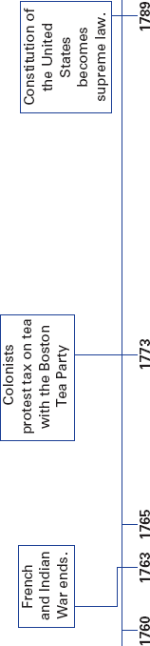

78
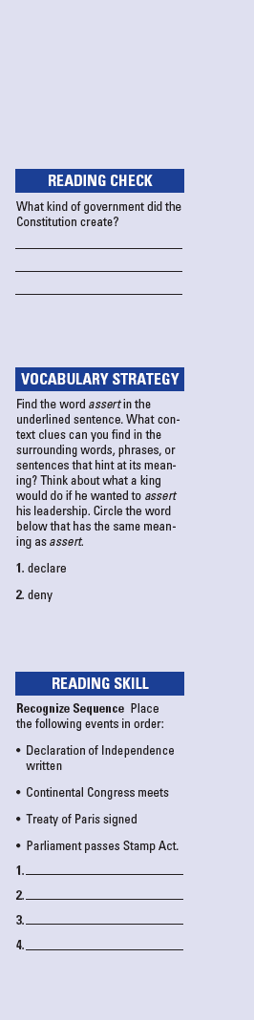
Name Class Date

In the mid-1700s, Britain was a global power. The new king,
George III, wanted to assert his leadership and expand his
rule. Britain’s huge territories included colonies in North
America. However, society and politics in these colonies devel-
oped in their own way. Some colonists began to feel that
maybe they would do better if they did not belong to Britain.
Tensions between the colonists and Britain grew. The
British Parliament passed laws, such as the Stamp Act, that
increased colonists’ taxes. The colonists felt they should not be
taxed because they had no one to speak for them in the British
Parliament. A series of violent clashes with British soldiers
strengthened the colonists’ anger. Leaders from each colony,
including George Washington, met in a Continental Congress
to decide what to do. In April 1775, however, tensions exploded
into war. The American Revolution began.
On July 4, 1776, American leaders adopted the Declaration
of Independence. Written mostly by Thomas Jefferson, it
includes John Locke’s ideas about the rights to “life, liberty,
and property.” It outlines the reasons for wanting to be free of
British rule and claims popular sovereignty. This principle
states that all government power comes from the people.
At first, it did not look like the Americans could win.
Britain had trained soldiers and a huge fleet. However, later
France and other European nations joined the American side,
and helped bring about the British surrender at Yorktown,
Virginia. In 1783, the Treaty of Paris ended the war.
Leaders of the new American nation, such as James
Madison and Benjamin Franklin, wrote the Constitution creat-
ing a federal republic. The new government was based on the
separation of powers, an idea borrowed from Montesquieu, an
Enlightenment thinker. The Constitution included the Bill of
Rights, which listed basic rights that the government must
protect.
Review Questions
1. Why did colonists feel they should not be taxed?

2. What ideas of John Locke are in the Declaration of
Independence?

79

