Name Class Date

One of the most dramatic accounts of the French Revolution was written by British
novelist Charles Dickens (1812–1870), who had not even been born at the time. This
excerpt from his novel A Tale of Two Cities describes a real event—the storming of the
Bastille on July 14, 1789. In the novel, leaders of the mob include the fictional
wineshop owner Defarge and his wife. ♦ As you read, think about what it might have
been like to be surrounded by a wild mob. Then, on a separate sheet of paper, answer the ques-
tions that follow.

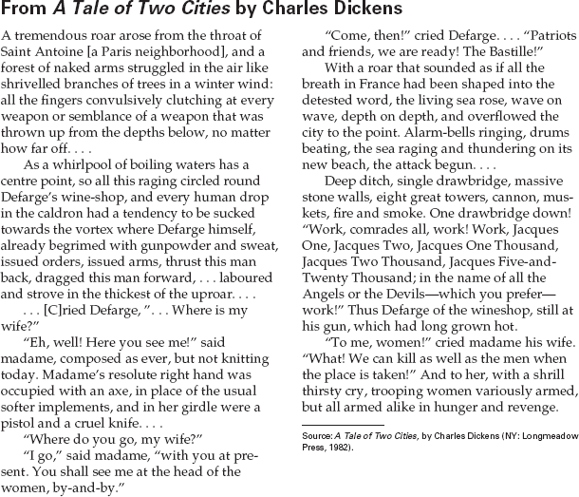

1. How do the people of Saint Antoine get
ready to attack the Bastille? What is their
mood?
2. What is Defarge’s role in the attack?
- Draw Inferences How do you know that the
people of Saint Antoine hate the Bastille and
everything it stands for?
- Draw Conclusions What does the character
of Madame Defarge say about the role of
women in the French Revolution?

29
Name Class Date

In the excerpts below, two newspapers report about the French Revolution and the
character and behavior of the revolutionaries. The first selection is from the London
newspaper The Times. It reports an event in which Paris radicals killed royalty and
aristocrats, as well as suspected royalists. The second article is from a radical Paris
newspaper, Le Père Duchesne. It paints quite a different portrait of the revolutionar-
ies. ♦ As you read, think about why these reports may have expressed such different views
on the French Revolution. Then, on a separate sheet of paper, answer the questions that follow.

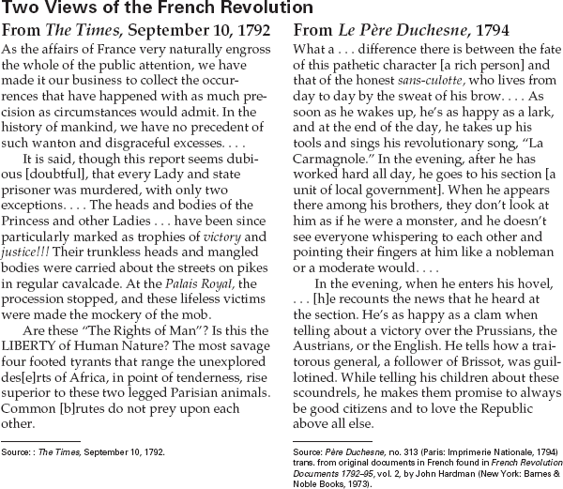

1. What negative comparison does The Times
article make?
2. How does the writer of the Le Père Duchesne
article characterize the sans-culotte?
3. Recognize Bias Why do you think these
newspapers expressed such different views
of the Revolution and the revolutionaries?

31
Name Class Date

The only member of the royal family to survive the French Revolution was the
young daughter of Louis XVI and Marie Antoinette, Marie-Therese Charlotte
de France, called “Madame Royale.” Along with her parents and her younger
brother, the Dauphin, she was imprisoned in 1792. The excerpts below are from
her memoirs. ♦ As you read, consider the many different ways of viewing the events of the
French Revolution. Then, on a separate sheet of paper, answer the questions that follow.
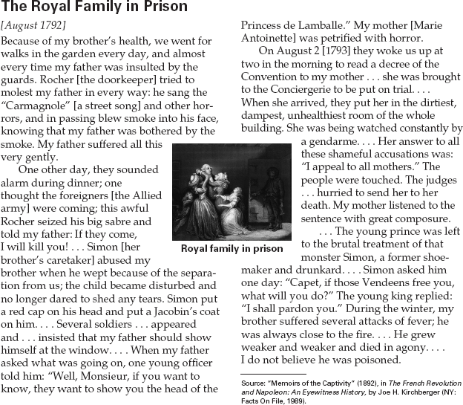

1. In what ways were various members of the
royal family harassed by the prison guards?
2. Recognize Bias What picture does Marie-
Therese try to give of her parents’ and
brother’s behavior in prison?
3. Activity Write a short letter to the editor of a
newspaper defending or objecting to the
treatment of the royal family in prison, on the
basis of humanitarian views or of the need
for revolution.

27
Name Class Date

Napoleon was a hero to many people in France, but others saw him as a tyrant.
One writer who bitterly opposed him—and was exiled from France—was Madame
Germaine de Staël (1766–1817). Napoleon’s soldiers, on the other hand, admired him,
as the speech made by one of his officers on Napoleon’s return to Paris in 1815
shows. ♦ As you read, think about what may have motivated each writer. Then, on a
separate sheet of paper, answer the questions that follow.

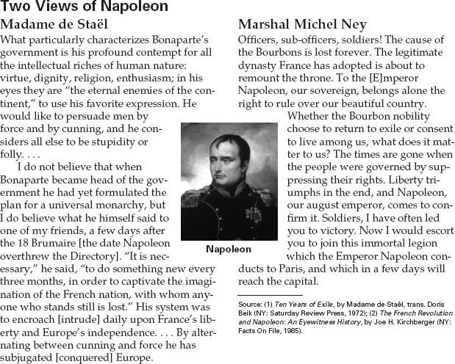

1. What does Madame de Staël say are
Napoleon’s only methods of persuasion?
2. What does Marshal Ney say about
Napoleon’s right to rule as opposed to that of
the Bourbon kings?
3. Make Comparisons Both these writers speak
about Napoleon and people’s liberty. How do
their views compare?

28

