Name Class Date

Focus Question: What led to the storming of the Bastille, and therefore,
to the start of the French Revolution?
As you read this section in your textbook, complete the following chart by identifying
the multiple causes of the French Revolution. Some items have been completed for you.

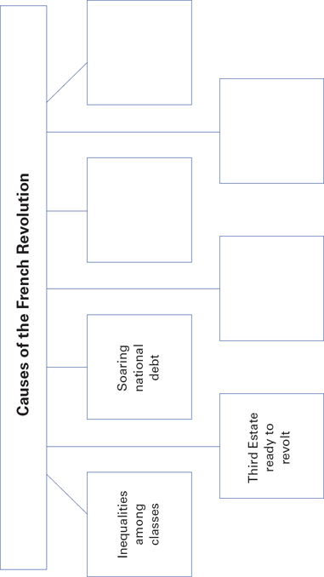

80
Name Class Date

Under France’s ancien régime, there were three social classes,
or estates. The clergy made up the First Estate. The nobles made
up the Second Estate. Everyone else, including the bourgeoisie,
or middle class, belonged to the Third Estate. Most of the Third
Estate was made up of rural peasants. Its poorest members
were urban workers.
Members of the Third Estate resented the privileges
enjoyed by the other classes. The First and Second Estates, for
example, paid almost no taxes. Yet peasants paid taxes on
many things. People began to question this inequality.
Economic troubles added to France’s social problems.
France was deeply in debt because of deficit spending. Bad
harvests sent food prices soaring. Louis XVI chose Jacques
Necker as his financial advisor. Necker proposed taxing the
First and Second Estates, but the nobles and high clergy forced
the king to dismiss him. As 1788 ended, France was nearly
bankrupt. Louis XVI called for the Estates-General to meet at
Versailles. The Estates-General was the lawmaking body made
up of the three classes. Before the meeting, the king had all
three estates prepare cahiers, or notebooks, listing their com-
plaints. The long lists of problems showed how deeply the
Third Estate resented the other two estates.
The Estates-General met in May 1789. Delegates of the
Third Estate took a daring step. They claimed to represent the
people of France and formed a new National Assembly.
Locked out of their meeting place, the delegates took their
famous Tennis Court Oath. They swore never to separate until
they had established a just constitution.
On July 14, 1789, the streets of Paris buzzed with rumors
that royal troops were going to occupy the city. A crowd gath-
ered outside the Bastille, a grim fortress used as a prison. They
demanded weapons that were stored there. When the com-
mander refused, the angry mob stormed the Bastille, sparking
the French Revolution.
Review Questions
1. What were the three classes during France’s ancien régime?

2. Why was France in debt?

165

Name Class Date

Focus Question: What political and social reforms did the National
Assembly institute in the first stage of the French Revolution?
As you read this section in your textbook, complete the following outline by identifying
the main ideas and supporting details in this section. Some items have been completed
for you.
I. Political crisis leads to revolt
A. The Great Fear
1. Inflamed by famine and rumors
2.
B. Paris Commune comes to power.
1.
2.
II. The National Assembly acts
A. Special privilege ends.
1.
2.
B. Declaration of the Rights of Man
1.
2.
C.
1.
2.
III. The National Assembly presses onward
A. The Church is placed under state control.
1.
2.
B.
1.
2.
C.
1.
2.

(Outline continues on the next page.)

82
Name Class Date

(Continued from page 82)
IV.
A.
1.
2.
B.
1.
2.
C.
1.
2.
D.
1.
2.

83
Name Class Date

In France, the political crisis of 1789 coincided with a terrible famine.
Peasants were starving and unemployed. In such desperate times,
rumors ran wild. Inflamed by famine and fear, peasants unleashed
their fury on the nobles. Meanwhile, a variety of factions in Paris
competed to gain power. Moderates looked to the Marquis de
Lafayette for leadership. However, a more radical group, the Paris
Commune, replaced the city’s royalist government.
The storming of the Bastille and the peasant uprisings pushed
the National Assembly into action. In late August, the Assembly
issued the Declaration of the Rights of Man and the Citizen. It
proclaimed that all male citizens were equal before the law. Upset
that women did not have equal rights, journalist Olympe de Gouges
wrote a declaration that provided for this. The Assembly did not
adopt it, however. Nor was King Louis XVI willing to accept reforms.
Much anger was directed at the queen, Marie Antoinette, who lived
a life of great extravagance.
The National Assembly produced the Constitution of 1791. This
document reflected Enlightenment goals, set up a limited monarchy,
ensured equality before the law for all male citizens, and ended
Church interference in government.
Events in France stirred debate all over Europe. Some applauded
the reforms of the National Assembly. Rulers of other nations, how-
ever, denounced the French Revolution. Horror stories were told by
émigrés who had fled France. Rulers of neighboring monarchies
increased border patrols to stop the spread of the “French plague” of
revolution.
In October 1791, the newly elected Legislative Assembly
took office, but falling currency values, rising prices, and food
shortages renewed turmoil. Working-class men and women, called
sans-culottes, pushed the revolution in a more radical direction, and
demanded a republic. The sans-culottes found support among other
radicals, especially the Jacobins. The radicals soon held the upper
hand in the Legislative Assembly. Eager to spread the revolution,
they declared war against Austria and other European monarchies.
Review Questions
1. What was the Declaration of the Rights of Man and the Citizen?
Why were some people dissatisfied with it?

2. How did rulers of European monarchies react to the French
Revolution?

84
Name Class Date

Focus Question: What events occurred during the radical phase of the
French Revolution?
As you read this section in your textbook, complete the following timeline to show the
sequence of events that took place during the radical phase of the French Revolution.
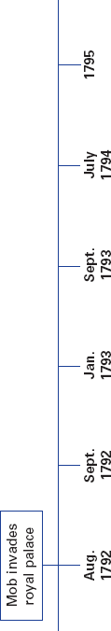

85
Name Class Date

In 1793, the revolution entered a dangerous and bloody phase.
Tensions rose between revolutionaries and those hoping to
restore the king’s power. On August 10, 1792, a mob stormed
the royal palace. Radicals called for the election of a new legis-
lature called the National Convention. Suffrage, or the right to
vote, was given to all male citizens, not just property owners.
The Convention that met in September 1792 was more
radical than earlier assemblies. It voted to end the monarchy
and establish the French Republic. Louis XVI and most of his
family were put on trial and beheaded.
Counter-rebellions inside France worried the Convention.
To deal with these, they created the Committee of Public
Safety. Maximilien Robespierre led the Committee. He helped
to create the Reign of Terror. The Terror lasted from Septem-
ber 1793 to July 1794. During that time, courts held trials for
those who resisted the revolution. Many were falsely accused.
About 17,000 people were beheaded by guillotine, including
Robespierre.
With Robespierre’s death, the revolution entered a less-
extreme stage. Moderates wrote the Constitution of 1795. It set
up a Directory of five men to lead the nation, and a two-house
legislature. However, rising prices and corruption remained.
To prevent chaos politicians then turned to military hero
Napoleon Bonaparte.
The French Revolution greatly changed France. The old
social order was gone. The monarchy was gone. The Church
was under state control. Nationalism, or strong feelings of
pride and love for one’s country, had spread throughout
France. From the city of Marseilles, troops marched to a
new song that later became the French national anthem.
Revolutionaries also made social reforms. They set up systems
to help the poor. They also ended slavery in some French
colonies.
Review Questions
1. What did the New National Convention do in 1792?

2. Identify one major change that the French Revolution
brought to France.

170
Name Class Date

Focus Question: Explain Napoleon’s rise to power in Europe, his
subsequent defeat, and how the outcome still affects Europe today.
As you read this section in your textbook, complete the flowchart to list the main
ideas about Napoleon’s rise to power and his defeat. Some items have been completed
for you.

Napoleon quickly advances through military ranks.

In 1802, Napoleon names himself consul for life.

In 1804, Napoleon assumes the title of Emperor of the French.

87
Name Class Date

The last phase of the revolution is known as the Age of
Napoleon. Napoleon Bonaparte started his rise to power as a
young officer. By 1804, he had become emperor of France. At
each step on his rise, Napoleon held a plebiscite. People voted,
but Napoleon always kept absolute power.
Napoleon made the central government stronger. All class-
es of people supported his economic and social reforms. One
of his most lasting reforms was the Napoleonic Code. This
new code of laws embodied Enlightenment principles of
equality, religious tolerance, and the end of feudalism.
From 1804 to 1812, Napoleon fought to create a vast French
empire. Before each battle, he drafted a completely new plan.
Because of this, opposing generals could never anticipate what
he would do next. He rarely lost. Napoleon annexed, or added
to his empire, most European nations except Russia and Britain.
He tried to wage economic warfare through the Continental
System. This system closed European ports to British goods.
Many Europeans did not like this blockade. In Spain, patriots
waged guerrilla warfare, or hit-and-run raids, against the
French.
In 1812, Napoleon invaded Russia. The Russians burned
crops and villages. This scorched-earth policy left the French
without food or shelter. The French retreated from Moscow
through the Russian winter. Only about 20,000 of 600,000 sol-
diers made it back to France alive.
The Russian disaster destroyed Napoleon’s reputation for
success. In 1815, British and Prussian forces crushed the French
at the Battle of Waterloo. Napoleon was forced to abdicate.
After Waterloo, European leaders met at the Congress of
Vienna. The Congress tried to create a lasting peace through
the principle of legitimacy, or restoring monarchies that
Napoleon had unseated. They also set up the Concert of
Europe to try to solve conflicts.
Review Questions
1. What reforms won support for Napoleon from all classes?
__________________________________________________
__________________________________________________
2. What destroyed Napoleon’s reputation for success?
__________________________________________________
__________________________________________________

172

