Name Class Date

The use of machines in manufacturing became widespread during the Industrial
Revolution. Below are two views regarding the impact industrialization had on soci-
ety. The first excerpt is by Thomas Carlyle, an English author and social critic. The
other excerpt is by Andrew Ure, a professor at the University of Glasgow and sup-
porter of the factory system. ♦ As you read, think about the writers’ reactions to the
changes brought about by advances in technology. Then, on a separate piece of paper, answer
the questions that follow.
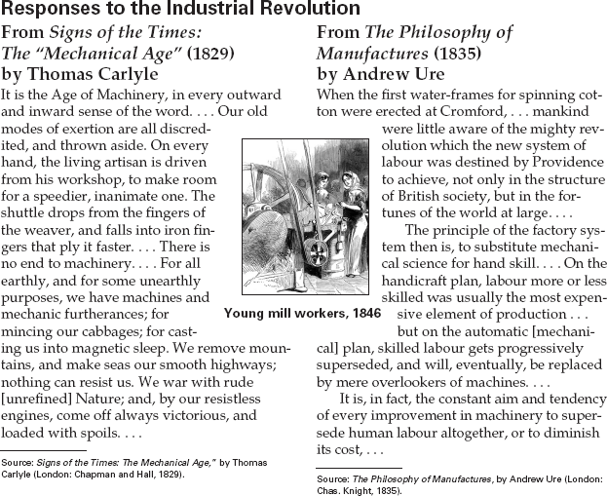

1. What examples does Carlyle give of workers
being replaced by machines?
2. According to Ure, what is the advantage of
using machines in manufacturing?
3. Recognize Cause and Effect Reread the first
paragraph of the excerpt by Carlyle. List one
cause and several effects of the Industrial
Revolution that he describes.

50
Name Class Date

Children were an important part of the workforce during the Industrial Revolution.
The jobs were often dangerous, and many labored long hours. Many started working
as early as age six. In the excerpts below, two nineteenth-century members of the
British Parliament offer their viewpoints on the child labor issue. ♦ As you read, think
about what it might have been like to work in a factory in the early 1800s. Then, on a separate
sheet of paper, answer the questions that follow.
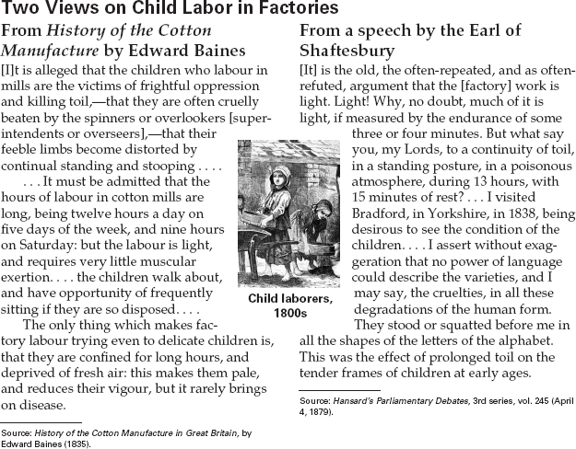

1. Explain each man’s viewpoint on the effects
of child labor in factories.
2. What effects of child labor did the Earl of
Shaftesbury see during his factory visit?
3. Identify Point of View Compare the points of
view set out in the two excerpts. Which
author do you think makes the best argu-
ment? Use supporting details or evidence
from the excerpt to support your answer.

47

