Name Class Date

Focus Question: What events helped bring about the Industrial
Revolution?
As you read this section in your textbook, complete the following flowchart to list
multiple causes of the Industrial Revolution. Some items have been completed for you.

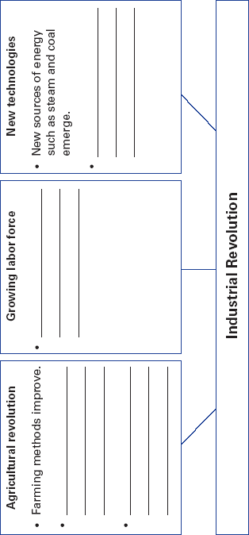

Name Class Date
89

The Industrial Revolution started in Britain. In 1750, most peo-
ple worked on the land using handmade tools. When the
Industrial Revolution began, the rural way of life in Britain
started to disappear. By the 1850s, many country villages had
grown into industrial towns and cities. New inventions and sci-
entific “firsts” appeared each year. For example, an American
dentist first used an anesthetic during surgery.
A series of related causes helped spark the Industrial
Revolution. It was made possible, in part, by another revolu-
tion—in agriculture. This agricultural revolution improved the
quality and quantity of food. Farmers mixed different kinds of
soils or tried new kinds of crop rotation to get higher yields.
Meanwhile, rich landowners pushed ahead with enclosure.
Enclosure is the process of taking over and consolidating land
once shared by peasant farmers. As millions of acres were
enclosed, farm output and profits rose. The agricultural revo-
lution created a surplus of food, so fewer people died from
hunger. Statistics show that the agricultural revolution con-
tributed to a rapid growth in population.
Agricultural progress, however, had a human cost. Many
farm laborers lost jobs. They then migrated to towns and cities.
There, they became the labor force that operated the new
machines of the Industrial Revolution.
Other factors that helped trigger the Industrial Revolution
were new technologies and new sources of energy and materi-
als. One vital power source was coal, used to develop the steam
engine. In 1764, Scottish engineer James Watt improved the
steam engine. Watt’s engine became a key power source. Coal
was also used to produce iron. Iron was needed to make
machines and steam engines. In 1709, Adam Darby used coal to
smelt iron, or separate iron from its ore. Darby’s experiments
led to the production of less expensive and better-quality iron.
Review Questions
1. How did the Industrial Revolution change rural life in
Britain?

2. What other revolution contributed to the start of the
Industrial Revolution?

90

Name Class Date

Focus Question: What key factors allowed Britain to lead the way in the
Industrial Revolution?
As you read this section in your textbook, complete the following concept webs to
identify causes and effects of Britain’s early lead in industrialization. Fill in the first
concept web with causes. Fill in the second concept web with effects. Some items have
been completed for you.

Causes
Population growth

Resources

Britain Takes
the Lead

Effects

Lower prices

Increased supply
of goods

Britain Takes
the Lead

91
Name Class Date

The Industrial Revolution began in Britain for several reasons.
Population growth was one. Another was Britain’s plentiful nat-
ural resources, such as rivers, coal, and iron. Also, the growing
population and ready workforce increased the demand for
goods. To increase production of goods, however, another key
ingredient was needed—money. Money was necessary to start
businesses. People accumulated capital, or money, to invest in
an enterprise, or business. Entrepreneurs managed and
assumed the financial risks of starting these new businesses.
The Industrial Revolution developed in Britain’s textile
industry. British merchants created the putting-out system. In
this system, raw cotton was given to peasant families. They
made it into cloth, in their homes. Production was slow, how-
ever. As the demand for cloth grew, inventors came up with
new machines, such as the flying shuttle and the spinning
jenny. These increased production and revolutionized the
British textile industry. Meanwhile, in the United States, peo-
ple had to figure out how to produce enough cotton to keep up
with these faster spinning and weaving machines. The cotton
gin, invented by Eli Whitney, greatly increased the production
of cotton. To house these new machines, manufacturers built
the first factories. There, spinners and weavers came each day
to work, instead of staying at home.
As production increased, people needed faster and cheaper
ways of moving goods, too. Some capitalists invested in
turnpikes. These toll roads soon linked every part of Britain.
The invention of the steam locomotive spurred the great rev-
olution in transportation. It made the growth of railroads possi-
ble. The world’s first major rail line ran between the British
industrial cities of Liverpool and Manchester. It started running
in 1830. In the following decades, railroad travel became faster
and railroad building boomed. As you can see, each change led
to another, rapidly affecting the way people lived.
Review Questions
1. How did population growth lead to the Industrial
Revolution?

2. How did machines change the textile industry?

92
Name Class Date

Focus Question: What were the social effects of the Industrial
Revolution?
As you read this section in your textbook, complete the following table to understand
the effects of industrialization. Some items have been filled in for you.
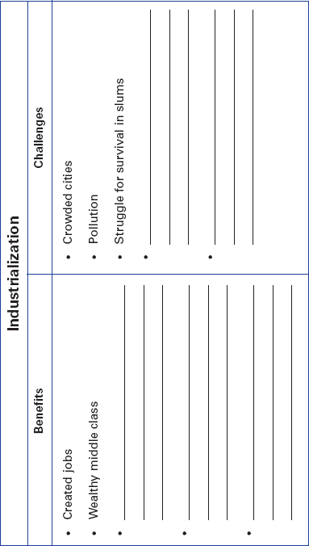

Name Class Date

The Industrial Revolution brought urbanization, or the move-
ment of people to cities. Masses of people moved from farms to
cities because of changes in farming, soaring population
growth, and demand for workers. Almost overnight, small vil-
lages around mines grew into cities. Other cities grew up
around the factories that were built in once-quiet market towns.
Those who benefited most from the Industrial Revolution
were entrepreneurs. They made up a new middle class created
by the Industrial Revolution. The wealthy and the middle class
lived in nice neighborhoods. The poor lived in crowded tiny
rooms in tenements, multistory buildings divided into apart-
ments. These tenements had no running water and no sewage
or sanitation system. Sewage rotted in the streets or was
dumped into rivers, which contaminated drinking water and
created an awful stench. This led to the spread of diseases.
Working in a factory system was very different from work-
ing on a farm. In rural villages, people worked hard, but the
amount of work varied with each season. The factory system
was a harsh new way of life. Working hours were long. Shifts
lasted from twelve to sixteen hours, six or seven days a week.
Tired workers were injured by machines that had no safety
devices. Working conditions in mines were even worse than in
the factories. Factories and mines also hired many boys and
girls. These children often started working at age seven or
eight, a few as young as five.
The early industrial age brought terrible hardships. In time,
however, reformers pressed for laws to improve working con-
ditions. Labor unions, or workers’ organizations, won the
right to ask for better wages, hours, and working conditions.
Despite the social problems created by the Industrial
Revolution, it did have some positive effects. More jobs were
created and wages rose. As the cost of railroad travel fell,
people could travel farther for less money than ever before.
Review Questions
1. Why did people migrate from farms to cities during the
Industrial Revolution?

2. What were working conditions like in factories?

94

Name Class Date

Focus Question: What new ideas about economics and society were
fostered as a result of the Industrial Revolution?
As you read this section in your textbook, complete the following outline to identify
main ideas about the new economic and social theories. Some items have been
completed for you.

I. Laissez-faire economics
A. Adam Smith and free enterprise
1.
2.
II. Malthus on population
A. Malthus holds bleak view.
1. Population will outpace food supply.
2.
3.
B. Ricardo shares view.
1.
2.
III. Utilitarians for limited government
A. Goal of society should be “the greatest happiness for the greatest
number.”
1.
2.
IV. Socialist thought emerges
A. Focus should be on the good of society in general, not on
individual rights.
1.
2.
B. Socialists establish utopian communities.
1. Hoped that equality among people would end conflict
2. Utopian industrialist Robert Owen sets up a model community
in Scotland.

Name Class Date

(Continued from page 95)
V. Karl Marx explains class struggle
A.
1.
2.
VI.
A.
1.
2.
3.
B. Marxism loses appeal.
1.
2.

Name Class Date

Many thinkers tried to understand the great changes taking
place in the early Industrial Age. Middle-class business leaders
supported the laissez-faire, or “hands-off” approach. They
believed that a free market would help everyone, not just the
rich. However, one British laissez-faire economist, Thomas
Malthus, thought the poor would always suffer. He believed
population would grow faster than the food supply. He did
not think the government should help the poor. He believed
people should improve their own lives through hard work and
have fewer children.
Other thinkers sought to soften laissez-faire doctrines. They
felt some government help was needed. The British philosopher
and economist Jeremy Bentham supported utilitarianism. He
believed that the goal of society should be the “greatest happiness
for the greatest number” of citizens. Other thinkers, such as
John Stuart Mill, strongly believed in individual freedom, but
wanted the government to step in to prevent harm to workers.
To end poverty and injustice, some offered a radical solu-
tion— socialism. Under socialism, the means of production—
the farms, factories, railways, and other businesses—would be
owned by the people as a whole, not by individuals. Some early
socialists, such as Robert Owen, set up communities in which
all work and property were shared. They were called Utopians.
The German philosopher Karl Marx formulated a new theory.
His theory predicted a struggle between social classes that would
end in a classless society that he called communist. Marx wrote
that the struggles of the proletariat, or working class, would end
because wealth and power would be equally shared. In practice,
communism later referred to a system in which a small elite
controlled the economy and politics. In the 1860s, German
socialists adapted Marx’s beliefs to form social democracy, which
called for a slow transition from capitalism to socialism.
Review Questions
1. Why did middle-class leaders support laissez-faire
economics?

2. What did Jeremy Bentham believe the goal of society
should be?

97

