Name Class Date

As great cities mushroomed in the Industrial Revolution, city life changed. Some
people found great cities exciting; others found them appalling, even frightening. In
these two letters to their families, composer Felix Mendelssohn and historian
Thomas Carlyle give their views of London in the 1820s. ♦ As you read, think about
each writer’s reaction. Then, on a separate sheet of paper, answer the questions that follow.
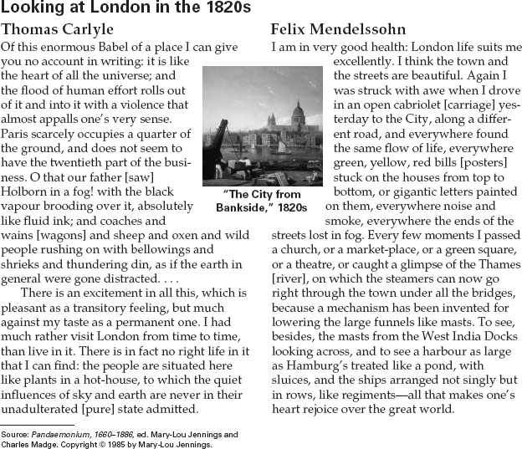

1. What aspects of the city of London make a
strong impression on both writers?
2. What signs of business and commerce does
Mendelssohn notice on the houses?
3. Make Comparisons In what ways do the two
writers agree in their reactions to the city of
London? How do their reactions differ?

9
Name Class Date

In Hard Times, Charles Dickens protests the dehumanizing conditions of factory life
in nineteenth-century England. In this excerpt from the novel, Dickens describes early
morning in a fictional factory town named Coketown. (Coke is a form of coal.) In
Coketown, people work under the harsh conditions of the early Industrial Revolution.
♦ As you read, think about what it might have been like to work in a factory like the one
described in this excerpt. Then, on a separate sheet of paper, answer the questions that follow.

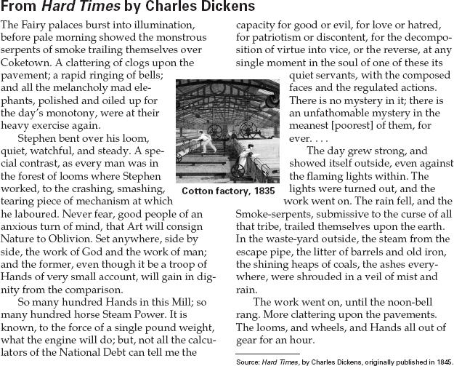

1. What kind of work does Stephen do?
2. According to Dickens, what is it impossible to
calculate?
3. Draw Inferences Why does Dickens refer to
the workers in the factory as “Hands”?
4. Draw Conclusions Based on this excerpt,
what is Dickens’ general attitude toward the
Industrial Revolution?

10

