Name Class Date

Focus Question: How did science, technology, and big business promote
industrial growth?
As you read this section in your textbook, complete the following chart to identify
main ideas about the major developments of the Industrial Revolution. Some items
have been completed for you.
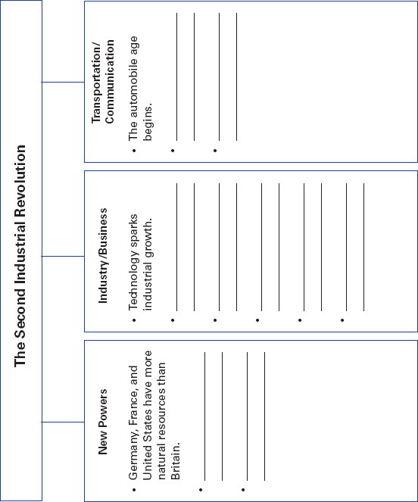

Name Class Date

For a while, Britain was the world’s industrial leader. By the
mid-1800s, however, Germany and the United States had
become the new leaders. These nations had much more coal,
iron, and other natural resources than Britain did. They also
were able to use British experts and technology. As in Britain,
cities in the new industrial nations grew quickly.
Technology helped industry grow. Henry Bessemer
invented a new way to make steel from iron. Alfred Nobel
invented dynamite for use in construction. Michael Faraday
created the first dynamo, a machine that makes electricity.
Soon electricity replaced steam as the main power source for
industry. In the 1870s, the American inventor Thomas Edison
developed the electric light bulb. Soon entire cities were lit
with electric lights. Factories could now operate at night and
produce more goods. The use of interchangeable parts and the
assembly line made production faster and cheaper, too.
Technology also changed transportation and communica-
tion. Steamships replaced sailing ships. Trains quickly con-
nected cities and brought raw materials to factories. The
invention of the internal combustion engine led to the mass
production of automobiles. In 1903, Orville and Wilbur
Wright launched the air age by flying a plane for a few sec-
onds. The telegraph and telephone made the exchange of
information nearly instantaneous. Guglielmo Marconi
invented the radio, a big part of today’s global communication
network.
These new technologies needed large amounts of money.
To get this money, owners sold stock, or shares in their compa-
nies, to investors. These businesses became giant corporations.
Others formed business groups called cartels. By the late
1800s, what we call “big business” came to dominate industry.
Review Questions
1. How did Germany and the United States become industrial
leaders?

2. What new form of energy changed cities and factories?

Name Class Date

Focus Question: How did the Industrial Revolution change life in
the cities?
As you read this section in your textbook, complete the following outline to identify
main ideas and supporting details about how the Industrial Revolution changed life
in the cities. Some items have been completed for you.
I. Medicine and the population explosion
A. The fight against disease
1.
2.
B. Hospital care improves.
1.
2.
II. Life in the cities
A. City landscapes change.
1.
2.
B.
1.
2.
C.
1.
2.
D.
1.
2.
III. Working-class struggles
A.
1.
2.
B.
1.
2.

Name Class Date

Between 1800 and 1900, the population of Europe more than
doubled. This was due to advances in medicine that slowed
death rates. In the fight against disease, scientists studied germ
theory. They believed that certain germs might cause specific
diseases. In 1870, French chemist Louis Pasteur showed the
link between germs and disease. German doctor Robert Koch
identified the cause of tuberculosis, a deadly lung disease.
British hospital reformer Florence Nightingale raised stan-
dards of care and cleanliness. British surgeon Joseph Lister dis-
covered that antiseptics prevent disease. As people understood
what causes disease, they practiced better hygiene. Disease
decreased and fewer people died.
At this time, cities underwent big changes in Europe and the
United States. The largest urban renewal project took place in
Paris in the 1850s. Old, crowded areas of the city were replaced
with wide avenues and grand public buildings. Steel made it
possible to build tall buildings called skyscrapers. Paved streets
helped make cities more livable. Electric streetlights illuminated
the night and increased safety. Huge new sewage systems made
cities healthier. City planners knew they needed to provide
clean water. These acts helped cut death rates.
Despite these efforts, cities were still harsh places for the
poor. In the worst slums, whole families lived in a single room.
However, millions of people still moved to the cities. They
came to get work, for entertainment, and for an education.
Most people worked long hours in factories, in unsafe cir-
cumstances for low wages. Workers protested these terrible
conditions. They formed mutual-aid societies to help sick or
injured workers. They also organized unions. Pressured by
unions, reformers, and working-class voters, governments
passed laws that improved working conditions. Wages varied,
but overall, the standard of living for most workers did rise.
Review Questions
1. How did advances in medicine increase population?

2. How did new sewage systems make city life healthier?

Name Class Date

Focus Question: How did the Industrial Revolution change the old social
order and long-held traditions in the Western world?
As you read this section in your textbook, complete the following table. List new
issues in the first column and write two supporting details for each issue in the
second column. Some items have been completed for you.
Changes in Social Order and Values

Change
Issue
Upper class: old nobility, new industrialists,
business families
New social order

Growing middle class develops its own way
of life.

Rights for women

Growth of public
education

New directions in
science

Name Class Date

In the late 1800s, many new issues challenged the old social
order. For centuries, mainly the two classes had been nobles
and peasants. Now a more complex social structure developed
with several social classes. The new upper class included very
rich business families. Below the upper class was a growing
middle class and then a struggling lower middle class. At the
bottom were workers and peasants. The middle class had its
own values and way of life, including a cult of domesticity.
This encouraged women to stay home and care for the family.
Demands for women’s rights also challenged the old social
order. Women sought fairness in marriage, divorce, and prop-
erty laws. In the United States, reformers such as Elizabeth
Cady Stanton and Sojourner Truth worked for women’s
suffrage, or the right to vote. Women’s groups also supported
the temperance movement, a campaign to limit or ban the use
of alcoholic beverages.
Attitudes toward education changed, too. People believed
that education would create better workers. Reformers per-
suaded many governments to set up public schools and require
basic education. Because of this, more children got an education.
New ideas in science also brought change. John Dalton
developed atomic theory. However, the most controversial new
idea came from British naturalist Charles Darwin. It upset
many people, who disagreed with his theory. Darwin thought
that all forms of life evolve over millions of years. His theory of
natural selection explains how members of each species com-
pete to survive. Some people used a twisted version of
Darwin’s theory, called Social Darwinism, to support racism.
Religion continued to be a force in Western society. Life in
industrial societies could be very cruel for some. Religious
groups tried to help the working poor. For example, the social
gospel movement urged Christians to work to improve society.
Review Questions
1. Who was included in the new upper class of the late 1800s?

2. What rights did women want?

Name Class Date

Focus Question: What artistic movements emerged in reaction to the
Industrial Revolution?
As you read this section in your textbook, complete the following table. Identify
supporting details about the major features of artistic movements of the 1800s. Some
items have been completed for you.
Charles Dickens
Victor Hugo
William Wordsworth
William Blake
Samuel Taylor
Coleridge
Major Figures
To capture the first fleeting
impression made by a scene
or object on the viewer’s eye
To represent the world as it
was, without romantic
sentiment
Rebellion against reason
Emphasis on imagination,
freedom, and emotion
Use of direct language,
intense feelings, glorification
of nature
Goals/Characteristics
Postimpressionism
Impressionism
Realism
Romanticism
Movement
Major Artistic Movements of the 1800s

110

Name Class Date

From about 1750 to 1850, a cultural movement called
romanticism emerged. It was a reaction against the ideas of
the Enlightenment. Romanticism emphasized imagination,
freedom, and emotion. The works of romantic writers included
direct language, intense feelings, and a glorification of nature.
William Wordsworth, William Blake, and Lord Byron were
major romantic poets. Romantic writers, such as Victor Hugo,
were inspired by history, legend, and folklore. Composers also
tried to stir deep emotions. The passionate music of Ludwig
van Beethoven used an exciting range of sound. Painters, too,
broke free from the formal styles of the Enlightenment. They
used bold brush strokes and colors to capture the beauty and
power of nature.
However, in the mid-1800s, an art movement called realism
took hold. Realists wanted to portray the world as it truly was.
They rejected romantic beauty. Their works made people aware
of the often bleak life of the Industrial Age. Many realists
wanted to improve life for their subjects. The novels of Charles
Dickens, for example, shocked readers with images of
poverty, mistreatment of children, and urban crime. Painters,
such as Gustave Courbet, painted ordinary working-class men
and women.
A new art form, photography, also developed. Louis
Daguerre made some of the first successful photographs.
Photography made some artists question the purpose of realist
paintings when a camera made exact images. By the 1870s, one
group started a new movement called impressionism. Artists
such as Claude Monet wanted to capture the first impression
made by a scene on the viewer’s eye. By focusing on visual
impressions, artists showed familiar subjects in unfamiliar
ways. Later, the postimpressionist painter Vincent van Gogh
experimented with sharp brush lines and bold colors.
Review Questions
1. What qualities did romantics include in their works?

2. What was the goal of the impressionist artists?

