Name Class Date

The philosophers of ancient China often used parables—short, often humorous, stories—to
illustrate a moral or lesson about human nature. The parable below is from the writings of a
philosopher named Liezi, who is thought to have lived about the third or fourth century B.C.
Little is known of Liezi except that he had many followers and traveled throughout ancient
China, providing advice to the rulers of small states ♦ As you read, think about the lesson the story
teaches. Then, on a separate sheet of paper, answer the questions that follow.

The Man Who Forgot
There was a man in Sung by the name of
Huatse, who developed in his middle age a
peculiar malady [diseases or illness] of forget-
ting everything. He would take a thing in the
morning and forget about it at night, and
receive a thing at night and forget about it in
the morning. While in the streets he
forgot to walk, and while standing
in the house, he forgot to sit down.
He could not remember the past in
the present, and could not remem-
ber the present in the future. And
the whole family was greatly
annoyed by it. They consulted the
soothsayer and they could not
divine it, and they consulted the
witch and prayers could not cure it,
and they consulted the physician,
and the physician was helpless. But
there was a Confucian scholar in the country
of Lu who said he could cure him. So the fam-
ily of Huatse offered him the half of their
property if he should cure him of this strange
malady. And the Confucian scholar said:
“His malady is not something which can
be cured by soothsaying or prayer or medi-
cine. I shall try to cure his mind and change
the objects of his thought, and maybe he’ll be
cured.”
So he exposed Huatse to cold and Huatse
asked for clothing, exposed Huatse to hunger,
and Huatse asked for food, and shut Huatse
up in a dark room, and Huatse asked for
light. He kept him in a room all by himself for
seven days and cared not what he was doing
all this time. And the illness of
years was cured in a day.
When Huatse was cured and
learned about it, he was furious. He
scolded his wife and punished his
children and drove away the
Confucian scholar from his house
with a spear. The people of the
country asked Huatse why he did
so, and Huatse replied:
“When I was submerged in the
sea of forgetfulness, I did not know
whether the heaven and earth
existed or not. Now they have waked me up,
and all the successes and disappointments and
joys and sorrows and loves and hatreds of the
past decades have come back to disturb my
breast. I am afraid that in the future, the suc-
cesses and disappointments and joys and sor-
rows and loves and hatreds will continue to
oppress my mind as they are oppressing me
now. Can I ever recover even a moment of
forgetfulness?”

1. What did Huatse’s family do to try to find a
cure for his illness?
2. Why was Huatse angry that he had been
cured?
3. Recognize Cause and Effect What do you
think was the reasoning behind the scholar’s
cure for Huatse?
4. Identify Central Issues What lesson about
living a peaceful life do you think the philos-
pher was trying to teach with this story?

8
Name Class Date

Written about 1900 B.C., The Tale of Sinuhe is one of the world’s oldest stories. Its
author was an official in the pharaoh Amenemhet’s government during Egypt’s
Middle Kingdom. The title character, Sinuhe (SIN oo hay), tells how, while traveling,
he learned of the pharaoh’s murder. Fearing for his life in the coming struggle for
power, Sinuhe fled. After wandering through present-day Palestine and Lebanon, he
was invited by a chieftain to settle in Syria. This excerpt tells how the chieftain
treated him and what Sinuhe did for the local people, whom he calls Asiatics. ♦ As
you read, think about the reasons people have for treating strangers well or badly. Then, on a
separate sheet of paper, answer the questions that follow.
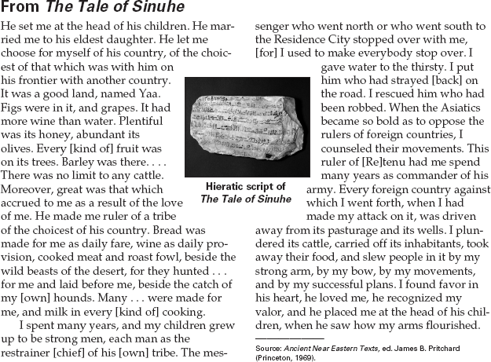

1. How does Sinuhe indicate that his new
home is a wealthy land with a powerful
ruler?
2. What happened to Sinuhe’s children in the
land of Yaa?
3. Draw Inferences What personal qualities did
Sinuhe possess? Describe his character,
using details from the story to support your
ideas.
4. Draw Conclusions Why do you think the
chieftain was so generous and helpful to
Sinuhe?

7
Name Class Date

Centuries after his death, the Egyptian high priest, master architect, and physician
Imhotep was deified, or elevated to the status of a god. He is one of only two
Egyptians born outside of royalty to attain this position. ♦ As you read, consider
Imhotep’s wide variety of achievements. Then, on a separate sheet of paper, answer the ques-
tions that follow.

Imhotep (2600s B.C.)
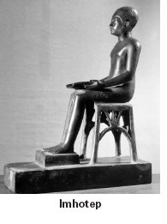
Imhotep, whose name means “he who comes
in peace,” was born a commoner in ancient
Egypt, in the Nile River city of Memphis. He
rose through the ranks to
become a vizier, or high-rank-
ing official, under the Third-
Dynasty king Djoser. In the
court of the king, Imhotep was
so trusted and influential that
his name was engraved in
honor on the base of a statue
of Djoser.
A wise and powerful man,
Imhotep was also a talented
sculptor, carpenter, astrologer,
magician, and an important
priest and scholar. As a high-
ranking official in the
pharaoh’s court, Imhotep
probably also served as the
nation’s chief physician. Perhaps his greatest
achievement during his lifetime, though, was
as an architect.
Before Imhotep’s time, Egyptian pharaohs
and their families were buried in large, low
rectangular tombs. Imhotep designed a com-
pletely new kind of structure at the cemetery
of Saqqarah in Memphis that featured six tiers
rising up in decreasing size. The 200-foot tall
structure has become known as the Step
Pyramid. Built in 2630 B.C. for Djoser, the
monument still stands today. The pyramid
was the world’s first large-scale stone struc-
ture. Surrounding the pyramid
were temples, a burial cham-
ber, sculptures, halls, and
pavilions. The large burial
complex was connected by
underground passages. For
centuries, the Step Pyramid
inspired the Egyptians to build
larger and more elaborate
pyramids.
Later generations of
Egyptians revered Imhotep as
the son of the mythological
creator of the universe, Ptah,
and the goddess of war and
pestilence, Sekhmet. The only
other mortal to be glorified as
a full deity was Amenhotep, a minister in the
Eighteenth Dynasty.
Imhotep’s reputation as a physician and
healer continued into Greco-Roman times. He
was worshipped as the god of medicine.
People who were ill flocked to healing tem-
ples built in Imhotep’s name in Memphis and
on the island of Philae. The sick often slept at
the temples and prayed that Imhotep would
reveal cures to them as they dreamed.

1. What was Imhotep’s position and reputation
in the court of King Djoser?
2. Why did people in Greco-Roman times flock
to the temples of Imhotep?

3. Draw Conclusions What does the physical
design and structure of the Step Pyramid and
the complex surrounding it tell you about the
Egyptian view of the afterlife? Explain your
answer.

Name Class Date

Some ancient civilizations created codes of laws defining rules of behavior within their societies.
The Code of Hammurabi, developed during the reign of the Babylonian king Hammurabi
(1792–1750 B.C.), organized Sumerian law that had existed for centuries. No codes of law have
been found for ancient Egypt, but the Instruction of Ke’gemni set out rules of proper conduct.
♦ As you read the selections, compare and contrast these codes of behavior. Then, on a separate sheet of
paper, answer the questions that follow.

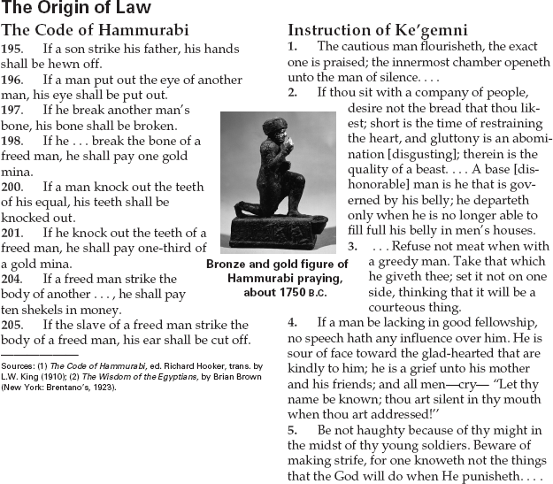

1. What are the two kinds of penalties for
breaking the law in the Code of Hammurabi?
2. What do the rules of conduct in the
Instruction of Ke’gemni say is the punish-
ment “for making strife”? Explain.
3. Draw Inferences Based on the rules of con-
duct in the Code of Hammurabi and the
Instruction of Ke’gemni, what are some infer-
ences you can draw about the differences
between the two societies?

5

