Name Class Date

In the Greek world, Athens and Sparta were rivals not only in politics, but also in
their overall approach to life, to education, and even to making war. Leaders in each
city defended their way of life. In the excerpts below, Pericles of Athens and King
Archidamus of Sparta describe some of their reasons for thinking their way of life is
best. Both speeches were recorded by the historian Thucydides. ♦  As you read, think
what these attitudes meant for ordinary people in each city-state. Then, on a separate piece of
paper, answer the questions that follow.
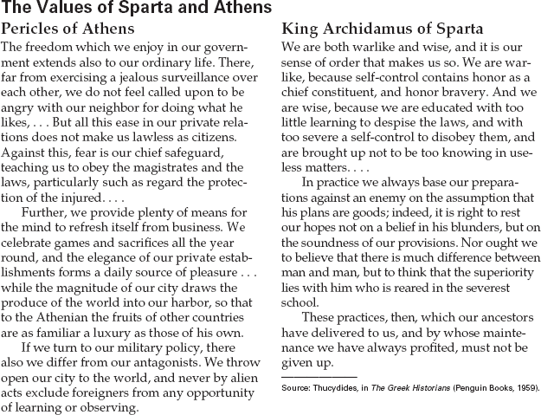

1. What qualities of Athenian life does Pericles
mention? How do these contrast with those
that Archidamus points out for Sparta?
2. According to Archidamus, what kind of per-son do Spartans consider superior?
3. Recognize Ideologies From his speech and
what you have read about Sparta, what kind
of learning do you think King Archidamus
would consider “useless matters”? Would an
Athenian agree?

19
Name Class Date

Sima Qian’s Records of the Grand Historian includes the accounts of Zhang Qian, a diplomat
Emperor Wudi sent on journeys to establish contact with peoples outside the Han empire.
Zhang traveled as far as the eastern edge of the Roman empire. His information about the rich
kingdoms he had seen led to the founding of the Silk Road, the legendary trade network con-
necting China and the western empires. ♦ As you read the excerpt, imagine the responsibility Zhang
Qian must have felt. Then, on a separate sheet of paper, answer the questions that follow.
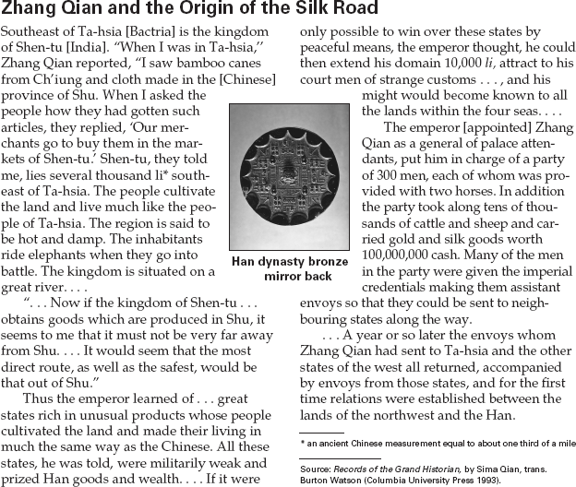

1. How did the people of Ta-hsia obtain goods
from Ch’iung and Shu?
2. Why did the emperor want to develop rela-
tions with distant states?
3. Recognize Cause and Effect The emperor
sent Zhang Qian and 300 men to Ta-hsia and
neighboring states. What was a result of the
journey?
4. Activity Research the Silk Road. On an out-
line map of Asia, draw the Silk Road and
label major civilizations that were linked by it.

18
Name Class Date

For centuries, feudalism was a way of life in Western Europe. Under feudalism,
powerful lords divided their landholdings among vassals, or lesser lords, in
exchange for service and loyalty. Everyone from the poorest peasant to the richest
king was touched in some way by feudal relationships. In this excerpt from the
1200s, a vassal promises his loyalty to a more powerful lord. ♦ As you read, think
about the different relationships that people can have with others. Then, on a separate sheet of
paper, answer the questions that follow.
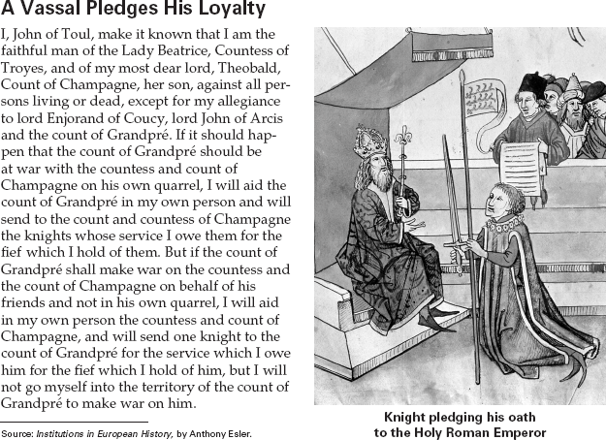

1. Which person in the excerpt is the vassal?
Who are the greater lords?
2. If the count of Grandpré helped another per-
son who had a quarrel with the count of
Champagne, what did John of Toul pledge
to do?

3. Analyze Information What weakness in the
feudal system does John of Toul’s pledge
show?
4. Activity Research the social levels or
classes in one European country during
feudal times, such as England, France, or
Spain. Write a report describing each level
in that society, including members and their
roles or jobs.

30
Name Class Date

The Magna Carta, or Great Charter, is at the foundation of Western democracy. King John of
England was forced to sign the document in 1215, and it asserts the rights of lords, called
barons. More importantly, however, the Magna Carta limits the power of the monarch. It
includes clauses that protected the rights of all free Englishmen and some clauses that applied
even to women. ♦ As you read, look for clauses in the Magna Carta that advanced individual liberties.
Then, on a separate sheet of paper, answer the questions that follow.

The Magna Carta
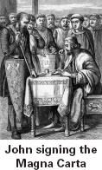
JOHN, by the grace of God King of England,
Lord of Ireland, Duke of Normandy and
Aquitaine, and Count of Anjou, to his arch-
bishops, bishops, abbots, earls, barons, jus-
tices, foresters, sheriffs, stewards,
servants, and to all his officials and
loyal subjects, Greeting. . . .
(8) No widow shall be compelled to
marry, so long as she wishes to
remain without a husband.
(13) The city of London shall enjoy
all its ancient liberties and free cus-
toms [trade], both by land and by
water. We also will and grant that all
other cities, boroughs, towns, and
ports shall enjoy all their liberties
and free customs.
(14) To obtain the general consent of the realm
for the assessment of an ‘aid’ [taxes] . . . we
will cause the archbishops, bishops, abbots,
earls, and greater barons to be summoned
individually by letter. . . to come together on a
fixed day (of which at least forty days notice
shall be given) and at a fixed place. [This is
the origins of Parliament.]
(20) For a trivial offense, a free man shall be
fined only in proportion to the degree of his
offense, and for a serious offense correspond-
ingly, but not so heavily as to deprive him of
his livelihood. . . None of these fines shall be
imposed except by the assessment on oath of
reputable men of the neighborhood.
(28) No constable or other royal offi-
cial shall take corn or other movable
goods from any man without imme-
diate payment, unless the seller vol-
untarily offers postponement of this.
(30) No sheriff, royal official, or
other person shall take horses or
carts for transport from any free
man, without his consent.
(38) In future no official shall place
a man on trial upon his own unsup-
ported statement, without produc-
ing credible witnesses to the truth of it.
(40) To no one will we sell, to no one will we
refuse or delay, right or justice.
(45) We will appoint as justices, constables,
sheriffs, or other officials, only men that know
the law of the realm and are minded to keep it
well.

1. Which clause deals with the concept of “the
punishment fitting the crime”?
2. Which clause protects citizens’ rights to a fair
trial?
3. Make Comparisons How are clauses 28 and
30 similar? Be specific.
4. Activity Suppose you were an English citizen
living in 1215. Write a letter to a relative
living outside of England. Explain how the
Magna Carta is changing people’s lives.

31

