Name Class Date

Ivan III of Moscow was declared his country’s co-ruler when he was a young boy.
His reign began as a way for his father, then the crown prince, to try to ensure his
family’s claim to the throne. During his more than 40 years as the grand prince of
Moscow, Ivan successfully led his country and helped complete the unification of
Russian lands. ♦ As you read, note events in Ivan’s life that happened for political reasons.
Then, on a separate sheet of paper, answer the questions that follow.

Ivan III (1440–1505)
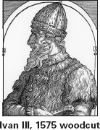
Ivan III, known as Ivan the Great, was born
into a family of rulers at a time when Russia
was besieged by struggles for power and ter-
ritory. Civil war raged between those who
supported his father, Crown Prince Vasily II
of Moscow, and those who supported Ivan’s
uncles. When Ivan was just six, his
father was arrested and blinded by
a cousin. Ivan was hidden in a
monastery before later being
handed over to his father’s captors.
His father was eventually
released, and to further establish the
family’s claim to the throne, Ivan,
then ten years old, was made a co-
ruler. Though he did not participate
in the governance of Moscow at
that young age, he did receive
experience in the arts of war and politics.
After his father’s death in 1462, Ivan
became the grand prince of Moscow. Ivan
centralized government by stripping some
princes of land and authority. He also started
the pomestie system, which granted estates to
servants of the grand prince on a lifetime
basis, on the condition of their loyal service.
Under Ivan’s rule, Moscow gained inde-
pendence from the Mongol Tatar empire of

the Golden Horde. Additionally, Russia’s
empire was expanded by the annexation of
major East Slavic principalities. One princi-
pality that Ivan acquired was Tver, which had
been Moscow’s major rival since 1300. Ivan’s
marriage to Maria, Princess of Tver, helped to
make the acquisition possible.
In 1467, Maria died, leaving
Ivan with one son, the heir to the
throne. To help secure his family’s
dynasty, Ivan married again, this
time to a niece of the last Byzantine
emperor.
After the death of Ivan’s son
from his first marriage, a battle
broke out over who would be
Ivan’s heir. The contenders were
Ivan’s son Vasily from his second
marriage and his grandson Dmitry, who was
his eldest son’s son. Ivan initially chose
Dmitry, but Vasily rebelled and defected to
the Lithuanians, bitter enemies of Russia. Ivan
then changed course. In 1502, he named
Vasily his co-ruler and sent Dmitry to prison.
Ivan’s last years were not eventful, and he
died in 1505. Despite his many achievements,
it is said that his people did not mourn his
passing.

1. What is the pomestie system?
2. How were Ivan III’s marriages politically
motivated?
3. Predict Consequences What might have hap-
pened in Russia had Ivan not changed course
and named Vasily as his successor?
4. Draw Conclusions Why do you think Ivan
chose the niece of the Byzantine emperor as
his wife?

32
Name Class Date

The Quran, the holy scriptures of Islam, contains 114 suras, or chapters. Muslims
believe that the Quran is the actual word of God, or Allah, as revealed to the prophet
Muhammad. This excerpt, from the second sura, tells believers what they should do
to be righteous and faithful Muslims. ♦ As you read, think about what different religions
require of their believers. Then, on a separate sheet of paper, answer the questions that follow.
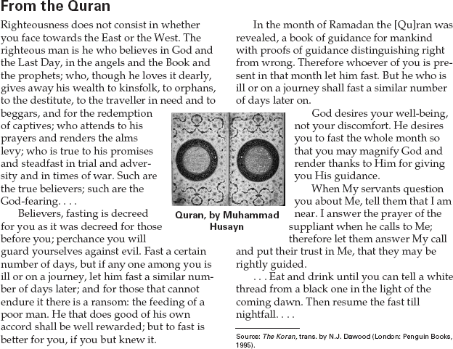

1. What must a Muslim do who cannot fast
during Ramadan?
2. At what point in the day do Muslims have to
stop eating and begin their fast?

3. Make Inferences The word Islam means “to
submit to God.” What evidence can you find
in this sura that submitting to the will of God
is important to Muslims?
4. Make Comparisons What does a Muslim
have to do to be righteous? How does this
requirement compare with the requirements
of other religions?

33

